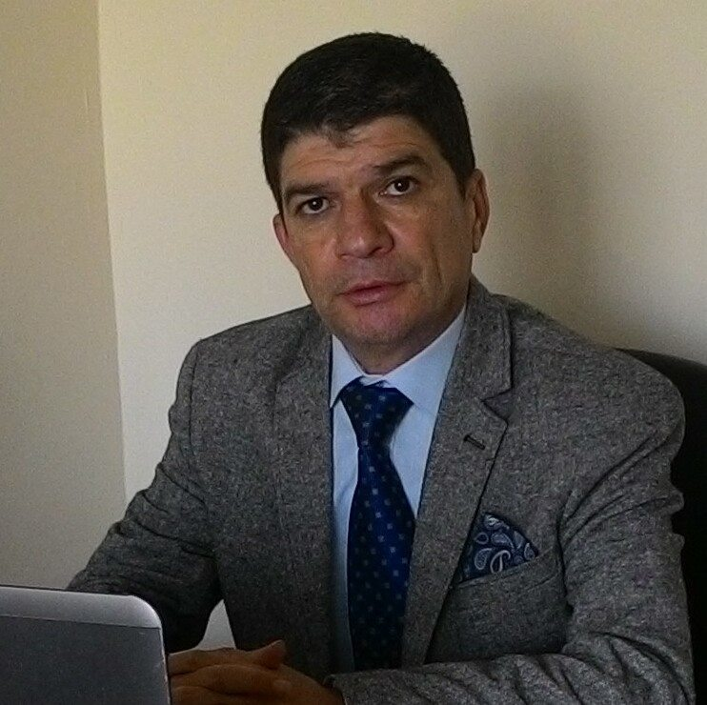

Curriculum Vitae

Personal Information
Name: | Mr.HENIR SADEEQ ISMAEL | Address: | Iraq-Duhok-Akre- 11 Aylol
Place & Date of Birth | IRAQ 14/03/1969 | Phone. No. | 00964 750 4526988
Marital Status: | Married | E-mail | hner3@yahoo.com

Employment Information
Profession | Teacher | Scientific Title & Acquiring Date
Work address | Duhok university/College of Science & Education /Akre

Academic & Scientific Degrees
Degree | Bachelor | Master
University Name | Mousl University | Fatih University
Degree granting country
Date of acquiring degree | 29/07/2007 | 28/7/2015
Fine Specialization | English Literature

Teaching Expertise
From | To | Scientific Subject Materials | University Name | Department
2015 | present | Literature | Duhok university | English Dept.
2015 | present | Phonetics | Duhok University | English Dept.
2015 | present | General English | Duhok polytechnic university | Finance College.

