Curriculum Vite

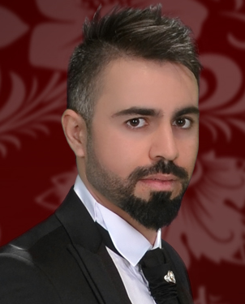
Azad Basheer Saadi

Personal Data

Surname: Saadi
Name: Azad Basheer
Gender: Male
Marital Status: Married
Nationality: Iraqi
Academic Status: chemical
Languages: Kurdish (mother tongue), English and Arabic (spoken good and written)
E-mail: azad.saadi@uod.ac
Mobile Phone: 00964 750 4593016

University

2006-2010 :
- B.Sc. study in the Dept. of Chemist, College of Science, the University of Duhok, Kurdistan, Iraq.
- Graduated from University of Duhok/ Faculty of Science/ department of Chemistry.
- Graduation Grade 70.39 % .
- MSc. degree in biochemistry in the Dept. of Chemist, College of Science, the University of Duhok , Kurdistan, Iraq in 2018.

Career Objectives:

I am a recent graduate who combined studies with working and other commitments. In achieving this, I have shown myself to be self-motivated, committed and determined in achieving my goals, come what may. I have also demonstrated negotiating and organizing skills, a firm sense of responsibility and my capacity to work hard under pressure. and I am able to relate to a wide range of people, as proven by my varied work experiences such as: trading jeans, markets, laboratory of disease, laboratory of fuel, factory of juice.

Work Experiences:

1- worked in a laboratory of ZAKI juice factory from 2010-2011
2- worked in a laboratory of ELECTRIC STATION ( department of fuel ) from 2011-2012.
3- worked in a laboratory tests from 2012-2015.
4- worked in world vision organization October 2016 to July 2017.

Professional Experiences:
- Working in Chemist laboratories.
- finished master degree.

Abilities and Skills
- Have a good working knowledge of computer, net & windows,
, Microsoft office( Word, Excel, ...).

Azad Basheer Saadi
azad.saadi@uod.ac
00964 750 4593016

