Faculty of Agriculture/ academic staff's biographies
Tutors Biography

Name: Khaleda Haji Abdullah Al-Botany
Scientific Title: Assistant lecturer in Rangeland management
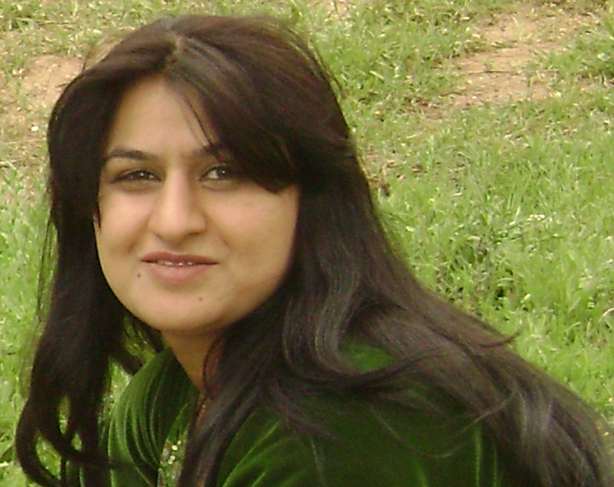
Contact Details:
+964(0)7504106355 @uod.ac
Research interests:
Research in progress:
Research web page: N/A
Publications:
Conference Proceedings: N/A
Other activity:
Teaching Experience:
Rangeland management, Third stage, Forest department 2014
Employment history:
2004 - 2005 I was working as a contract in college of agriculture
Since May 2005 2005-2009 Demonstrator at Forest Dept./ College of Agriculture
2012 Assistant Lecturer at Duhok University.
Teaching at Faculty of Agriculture and Forestry Sciences
Research at Forestry School

Society membership:
Member of the Kurdistan Agronomist Syndicate since 2004

Additional Information: N/A

Biography:
Obtained M.Sc.(2012) in Agriculture (Forestry science) from Forestry department /college of Agriculture and Forestry/ University of Mosul.
The master reaserch was under title (Plant biodiversity and forage value of the vegetation cover growing on the slopes surrounding Ashawa resort).
Khaleda H.A. is assistant lecturer at faculty of agriculture and forestry, Duhok university,. Moreover she had graduated from faculty of agriculture and forestry in (2001-2002), she worked as a demonstrator in a school of forestry in 2005 until 2008, after that she had studied postgraduate on Rangeland management (MSc.), furthermore, she has becoming an assistant lecturer in 2012, nowadays she is teaching third year student (rangeland management) and. About her languages skills, he knows Kurdish and Arabic languages fluently, and her skills in English language are good.

