dr.hajar bashir sadoon
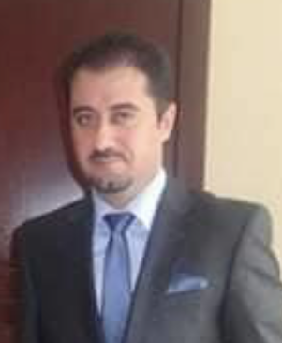

Personal Information
Name: | Hajar Bashir Kalari Sadoon | Address: | Duhok, Geverke
Place & Date of Birth | Zommar, 01/0-1/1978 | Phone. No. | 07514340901
Marital Status: | Married | University E-mail | Hajar.sadoon@uod.ac

Employment Information
Profession | University Staff | Scientific Title & Acquiring Date | Assistant Lecturer  12/10/2015
Type of Relationship with the University | Lecturer

Academic & Scientific Degrees
Degree | Bachelor | Master | PhD
University Name | University of Salahaddin | Nottingham Trent University | University of Exeter
Degree granting country | Kurdistan Region of Iraq | UK | UK
Date of acquiring degree | 01/10/2000 | November/2010 | 26/03/2018
Title of Master Thesis | The Kurdish Quais-State
Specialization | International Relations: Theories, Practices and Theories
Title of PhD Dissertation | From Foreign Relations to Foreign Policy: Transformation of the Kurdish De Facto State into an Independent Foreign Policy Actor, 1992-2011
Specialization | Political Sciences: Middle East Politics

Teaching Expertise
From | To | Scientific Title | University Name | Given(taught)Subject Materials
2015 | 2016 | Assistant Lecturer | Nawroz University | - Ancient Political Thought  - Globalization
2018 | 2019 | Assistant Lecturer | University of Duhok | - Ancient Political Thought  - Comparative Politics
2019 | 2020 | Assistant Lecturer | University of Duhok | - Comparative Politics  - Foreign Policy
2020 | 2021 | Assistant Lecturer | University of Duhok | - Introduction to the Study of Political Systems
2021 | 2022 | Assistant Lecturer | University of Duhok | 1- Introduction to the Study of Political Systems

Managerial Expertise
Name of the University or Institution | To | From
Head of the Department of Political Systems and Public Policy, College of Political Sciences, University of |Duhok | ongoing | 2020

Authored Translated Books
Date | Place of Publication | Name of the Book (title)
2020 | Kurdish Academy- Erbil | The Kurdish De Facto State: Foreign Policy Transitions and Trends

Scientific Researches
Date | Place of Publication | Research title
In the process | Journal of University of Duhok | The Foreign Relations of the Eylul Revolution: 1961-1975
n the process | Nawroz University | موقف الاوربي من حملات الانفال في كوردستان العراق 1988 فرنسا والسويد انموذجاً

Essays
Date | Place of Publication | Name of the Essay (title)

Conferences & WorkShop
Date | Type of Participation | Conference – WorkShop
09/2021 | Paper | The Position of the Kurdistan Region within Iraq

Current Postgraduate (PhD, M.Sc., & Academic Diploma) Supervision

No. | Student Name | University – College and Department | official Order No. & Date | Thesis Title
1
2
3
4

Syndicate or Organizations Membership
Kind of Membarship | Name of Organization or Syndicate

Academic Network

Website Name | Link
ORCID
Google Scholar | https://ore.exeter.ac.uk/repository/handle/10871/32229
Research Gate | https://www.researchgate.net/profile/Hajar-Sadoon-2
Publons
Linkedin | https://www.linkedin.com/in/hajar-sadoon-979ba521b/

