الأسم الثلاثي: Ari Mohammed Rashid
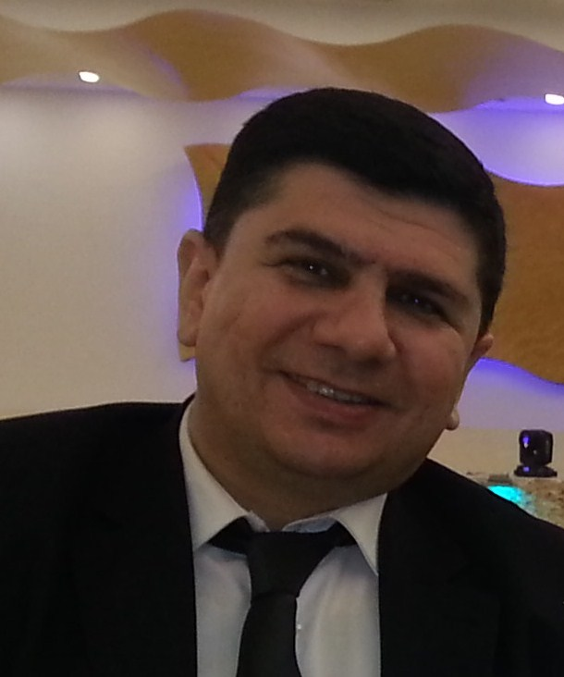
اللقب : مدرس مساعد
الشهادة : ماجستير محاسبة
المنصب: تدريسي
البريد الألكتروني: ariamedi@live.com
رقم التلفون: 07508391701
الأنشطة من 1/9/2015 – 31/8/ 2016:

Ari Mohammed Rashid
0750 8391701
Ariamedi@live.com
SUMMARY OF QUALIFICATIONS
- Master of Professional Accountancy.
- Assistant Lecturer at Duhok University since 2012.
- Speak three languages, Kurdish, Arabic and English.
- Linguist/translator.
- Graphic Specialist skills.
- Proficient in Microsoft Office applicatons.
- Fast Learner and detailed oriented.
EDUCATION
Georgia State University, Robinson College of Business, Atlanta, U.S.A. 2010 – 2011
- Master of Professional Accountancy
Atlanta Technical College, Atlanta, U.S.A. 1998-1999.
- Diploma Visual Communications.
- Member of the National Vocational Honor Society from 1998.
Salahaddin University, College of Administration and Economic, Erbil, Kurdistan, Iraq 1989-1993
- Bachelor of Accountancy.
WORK EXPERIENCE
Duhok University 3/2012 – present
Assistant Lecturer
- Teaching at the Accounting branch of the Faculty of Administration and Economic.
- Taught the classes of Advanced Accounting - English to the third year students, International Accounting and Specialized Accounting II to the fourth year students.

Nawruz University 2014-2016
Visiting lecturer teaching Principles of Accounting to the first year students of Economic branch.

From year 2000 – 2010
Linguist/Translator
- Interpret and translate between these languages: Kurdish, Arabic and English.

Label Art and Amerigraph Packaging Group, Atlanta, GA, 1998 –2000.
Pre-press Graphic Specialist.
- Graphic specialist in the Art room of label printing company.

Kurdistan Relieve Association (KRA) Duhok, Kurdistan, Iraq 1994-1996.
- Accountant assistant.
- Warehouse manager.
- Computer Operator of the company.

SKILLS

- Teaching skills (Assistant Lecturer at Duhok University).
- Professional linguist speaking Kurdish, Arabic and English languages.
- Proficient in MS Office and Adobe applications.
- Graphic Specialist.

