Personal Information |  |  |  |  |  |  |  |  | ph 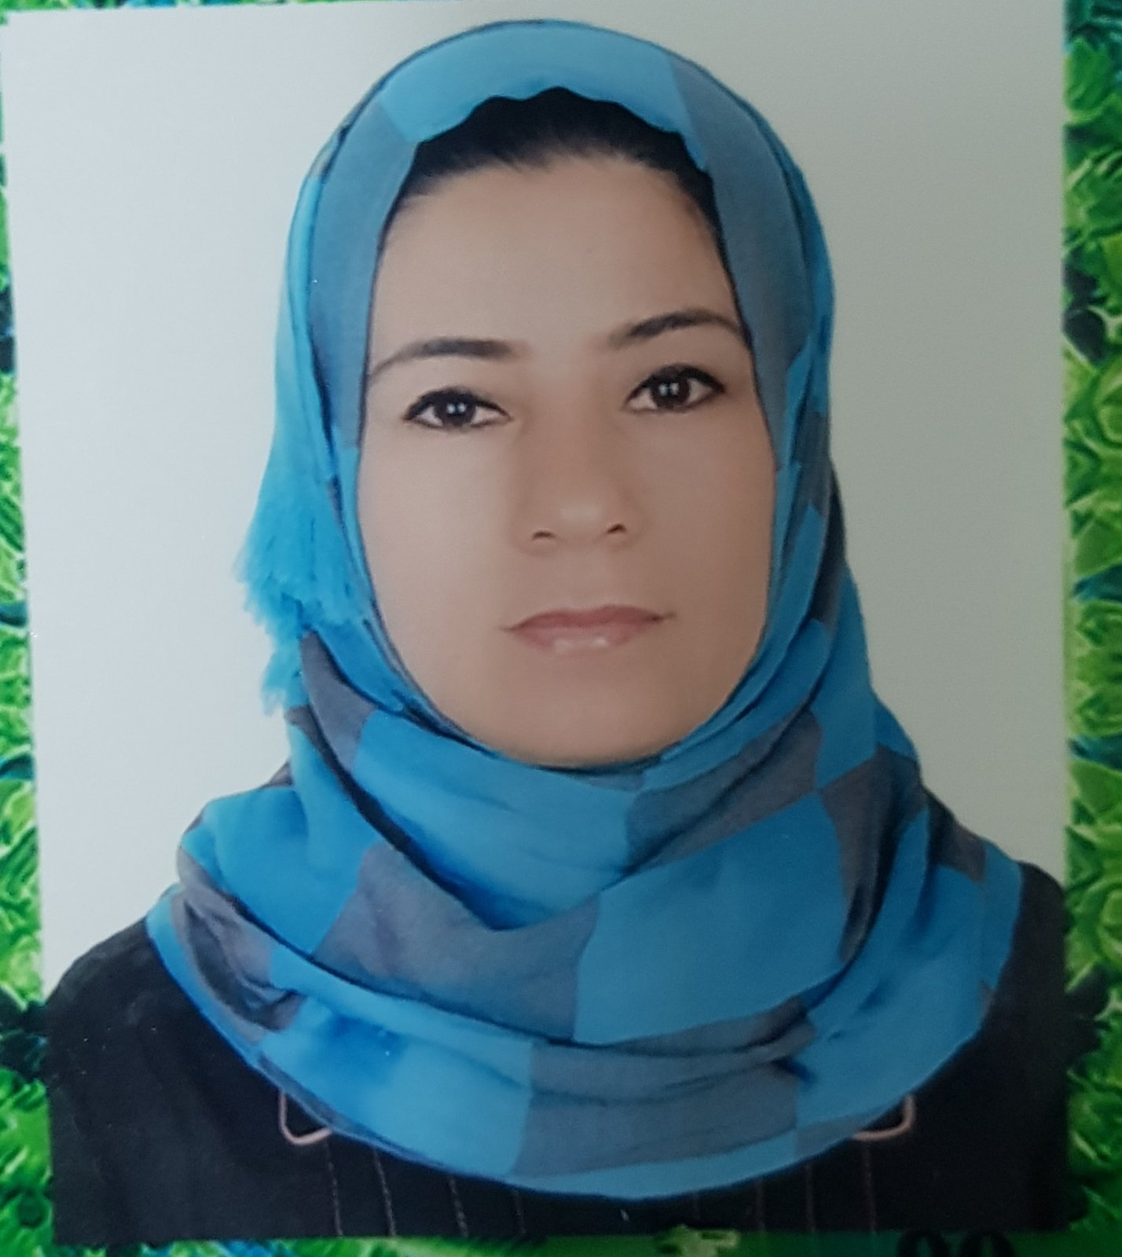 oto
Name |  | Izdihar Hadi Abdullah
Nationality |  | Iraqi
Date of Birth |  | 2/12/1982
Place of Birth |  | musol |  |  |  |  |  |  | Marital Status | Single
Contact Information
E-mail |  |  | akrahiizdihar@yahoo.com |  |  |  |  |  | E-mail |  | Izdihar.abdullah @uod.ac
Home Address  (Permanent Address) |  |  | Duhok |  |  |  |  |  | Mobile No. |  | 009647507292303
Education
Degree |  |  |  | Bachelor |  |  | Master |  |  |  |  | Scientific Title
University Name |  |  |  | University of Duhok |  |  | University of Duhok
Country |  |  |  | Duhok |  |  | Duhok
Date of obtaining degree (Day/Month/Year) |  |  |  | 7/7/2013 |  |  | 15/7/2021
Bachelor (Major /Specialization) |  |  |  |  |  |  | Business Administration
Master (Major / Specialization) |  |  |  |  |  |  | Financial management
Title of Master Thesis |  |  |  |  |  |  | The Determinants of Cryptocurrencies and their Impact on the Return and Risk of the Investment Portfolio with Reference to the Kurdistan Region / A comparative analytical study of the international stock market .
Title of PhD. Dissertation |  |  |  |  |  |  | /
Experience in University of Duhok- Iraq
From  D/M/Y | To  D/M/Y |  |  |  |  | Position /Title |  |  |  |  |  |  | Nature of work
10/10/2013 | 24/3/2019 |  |  |  |  | Research Assistant |  |  |  |  |  |  | Teaching Assistant
25/3/2019 | 4/4/2021 |  |  |  |  | Master student |  |  |  |  |  |  | student
5/4/2021 | Until now |  |  |  |  | Lecturer |  |  |  |  |  |  | Teach
Courses Taught
- Ielts Certificate. English proficiency. 2018
- English course 160-hour in Duhok university - Cultural Center for Development and Development 2014-2015.
- English course 120-hour in Duhok university - Cultural Center for Development and Development 2018-2019
Activities
Scientific Research Published |  |  |  |  |  |  |  | Journal /Institution |  |  |  |  |  | No. and Volume/Year
تقييم المعرفة المالية بالعملات المشفرة : دراسة استطلاعية لآراء عينة من مدراء وشركات FOREX في اقليم كوردستان |  |  |  |  |  |  |  | Academic Journal of Nawroz University (AJNU) |  |  |  |  |  | No. (10)  Volume (20)  /Year2020/2021
Conferences |  |  |  |  |  |  |  | University-City |  |  |  |  |  | Year
/
Subjects Teaching
Computer Skills
Software / Program |  |  |  |  | Level
ms Word |  |  |  |  | Very good
ms excel |  |  |  |  | Very good
ms Access |  |  |  |  | good
ms power point |  |  |  |  | Very good
Language Skills
Language |  |  |  |  | Level
Kurdish and Arabic |  |  |  |  | Very good
English |  |  |  |  | good
Other |  |  |  |  | /

