Personal Information |  |  |  |  |  |  |  |  | photo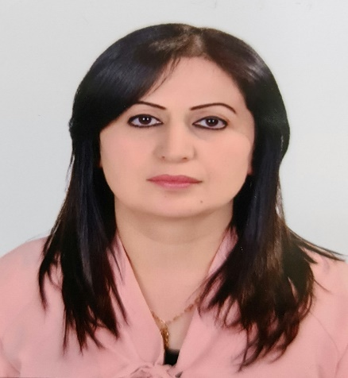
Name |  | Khalat Shukri qasim
Nationality |  | Iraq
Date of Birth |  | 1/4/1976
Place of Birth |  | duhok |  |  |  |  |  |  | Marital Status
Contact Information
E-mail |  |  | Xelatsukri76@gmail.com |  |  |  |  |  | E-mail |  | Khalat.qasim@uod.ac
Home Address  (Permanent Address) |  |  | Midya/Duhok |  |  |  |  |  | Mobile No. |  | 0096407504570796
Education
Degree |  |  |  | Bachelor |  |  | Master |  |  |  |  | Scientific Title
University Name |  |  |  | Duhok |  |  | Duhok
Country |  |  |  | Iraq |  |  | Iraq
Date of obtaining degree (Day/Month/Year) |  |  |  | 1999 |  |  | 2003
Bachelor (Major /Specialization) |  |  |  |  |  |  | Economic
Master (Major / Specialization) |  |  |  |  |  |  | Finance
Title of Master Thesis |  |  |  |  |  |  | Participatory Companies and The Fusibility of Establishing a Financial Market in the Kurdistan Region of Iraq
Title of PhD. Dissertation

Experience in University of Duhok- Iraq
From  D/M/Y | To  D/M/Y |  |  |  |  | Position /Title |  |  |  |  |  |  | Nature of work
2003 | 2004 |  |  |  |  | Rapporteur for the Department of Finance
2005 | 2006 |  |  |  |  | Head of the Commerce Department
2020 |  |  |  |  |  | Rapporteur for the Accounting Department
2020 |  |  |  |  |  | Examination committee member
2003 | 2021 |  |  |  |  | Lecturer |  |  |  |  |  |  | Teaching
Courses Taught
Activities
Scientific Research Published |  |  |  |  |  |  |  | Journal /Institution |  |  |  |  |  | No. and Volume/Year
Economic Evaluation Of Industrial Firms Medium And Large In Dohok Area In 2016 |  |  |  |  |  |  |  | Academic Journal of Nawroz University |  |  |  |  |  | https://doi.org/10.25007/ajnu.v7n1a157
Determinants of the industrial growth of some ASEAN countries for the period (1995-2015 |  |  |  |  |  |  |  | Academic Journal of Nawroz University |  |  |  |  |  | https://doi.org/10.25007/ajnu.v7n2a238
The Impact of Import Components on Economic Growth in Egypt, Standard Study for the Period (1991-2018) |  |  |  |  |  |  |  | Humanities Journal of University of Zakho |  |  |  |  |  | https://doi.org/10.26436/hjuoz.2020.8.3.633
Conferences |  |  |  |  |  |  |  | University-City |  |  |  |  |  | Year
Uses of G- Suit and its application/1 |  |  |  |  |  |  |  | University of Duhok |  |  |  |  |  | 2020/ 9/13
Uses of G- Suit and its application/2 |  |  |  |  |  |  |  | University of Duhok |  |  |  |  |  | 2020/ 9/14
Pedagogical Training and Academic Development Center |  |  |  |  |  |  |  | University of Duhok |  |  |  |  |  | 2020/ 9/15
Pedagogical Training and Academic Development Center |  |  |  |  |  |  |  | University of Duhok |  |  |  |  |  | 2020/ 9/15
Change/reset password, useful tools and creating an assignment - UoD training courses |  |  |  |  |  |  |  | University of Duhok |  |  |  |  |  | 2020/ 9/17
How to create a Quiz (Test): Multiple choices, true & false and writing an essay - UoD training courses |  |  |  |  |  |  |  | University of Duhok |  |  |  |  |  | 2020/ 9/28
Science and Academic teaching in times of crisis |  |  |  |  |  |  |  | Technical University of Dortmund |  |  |  |  |  | 15 / 6 / 2020
Let's get diverse-Towards a sustainable development after crisis |  |  |  |  |  |  |  | Technical University of Dortmund |  |  |  |  |  | /16 6 / 2020
Subjects Teaching
Principle of Economics – Principle of Statistics – Economic Statistics- National accounts – Money and banks – Scientific discussions – Search methods
Computer Skills
Software / Program |  |  |  |  | Level
Word |  |  |  |  | 5
Excel |  |  |  |  | 4
spss |  |  |  |  | 4
Power point |  |  |  |  | 4
Language Skills
Language |  |  |  |  | Level
Kurdish and Arabic |  |  |  |  | 5
English |  |  |  |  | 3
Other

