Personal Information |  |  |  |  |  |  |  |  | 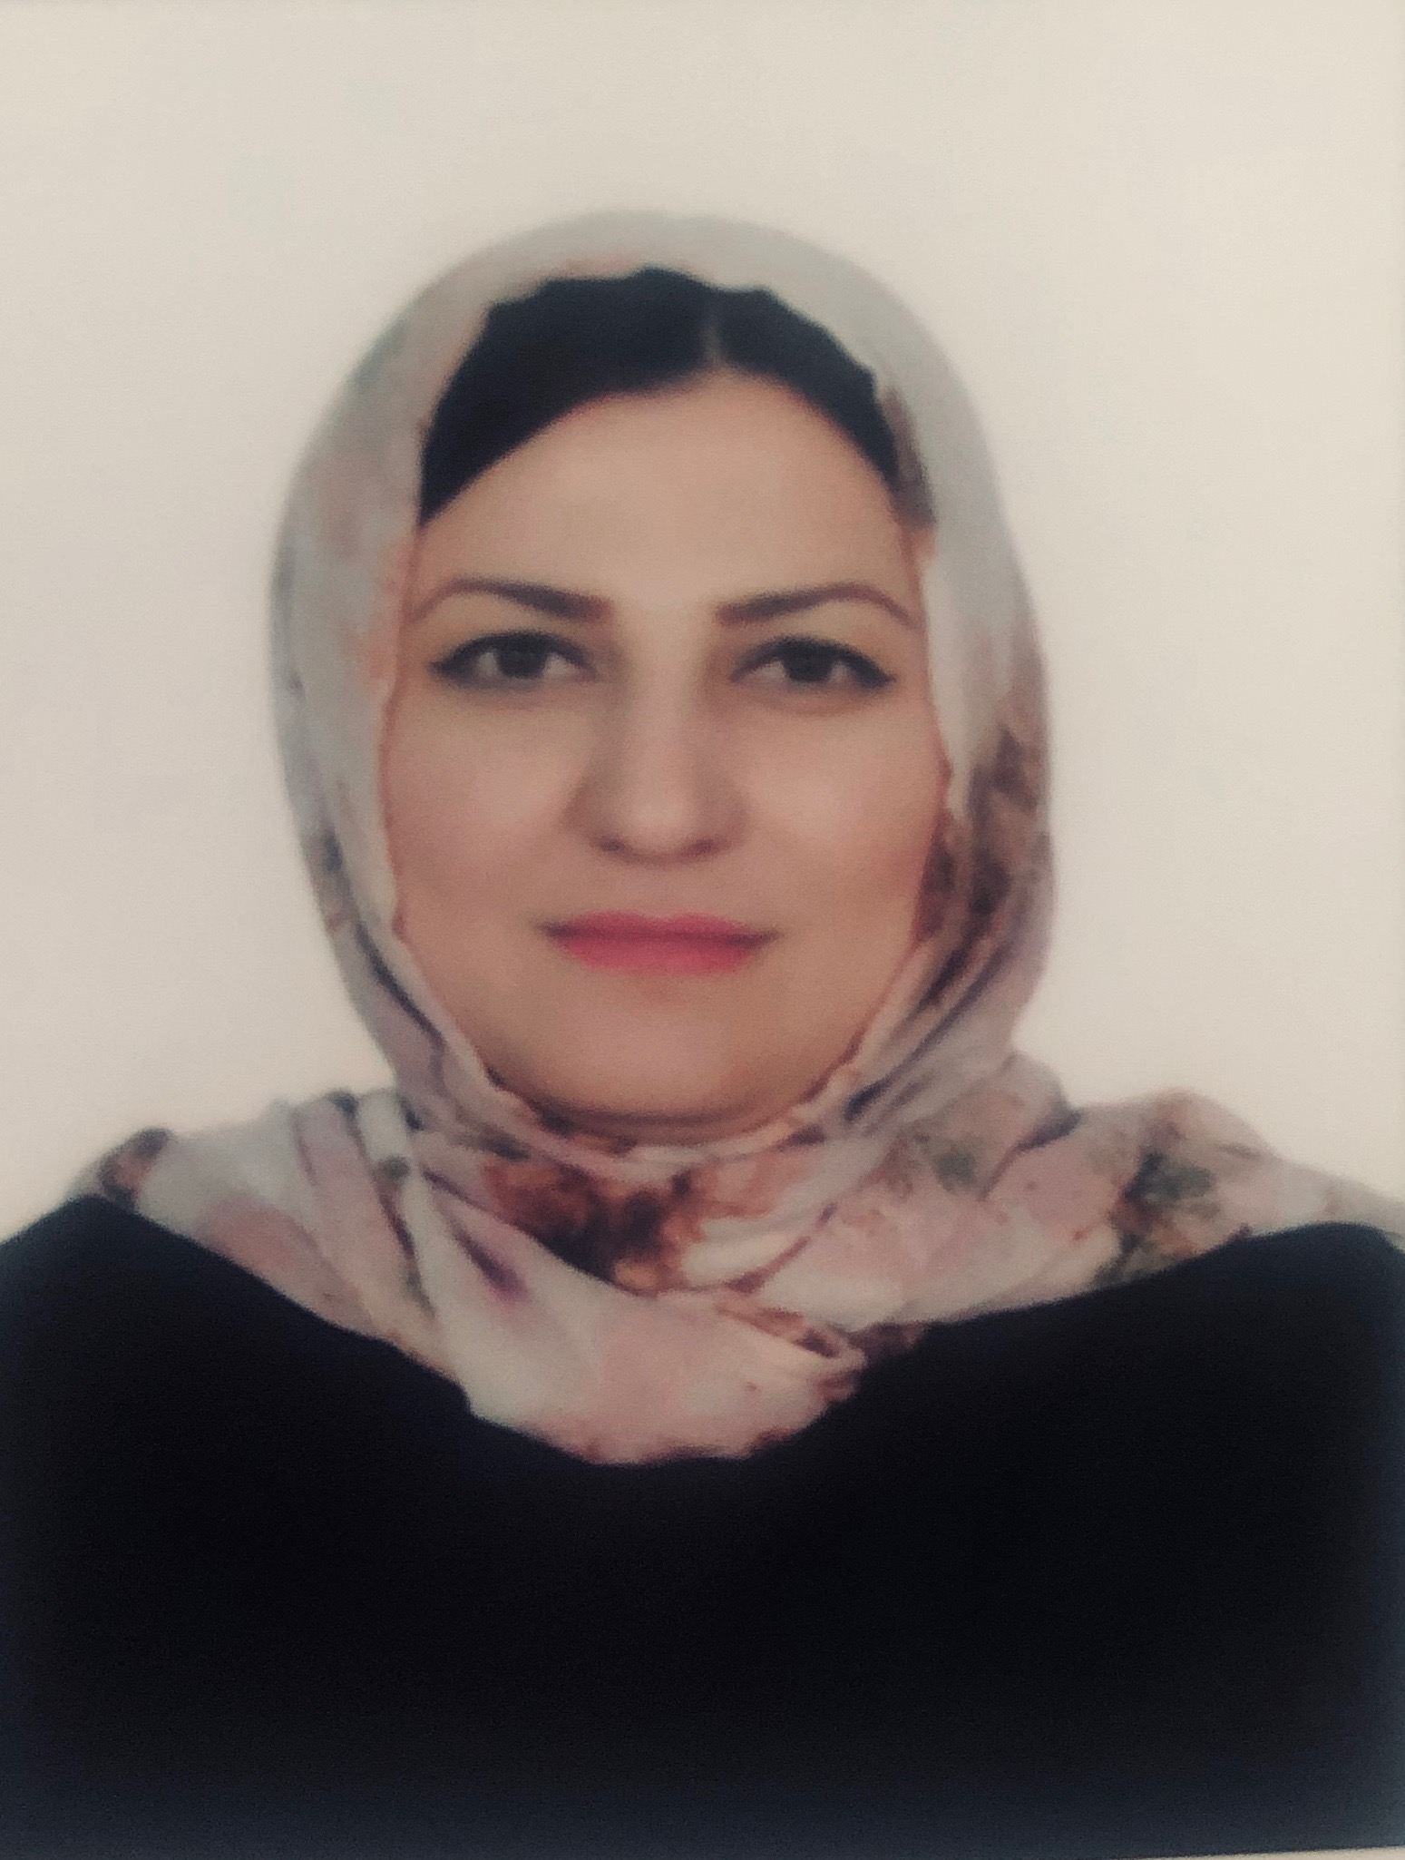
Name |  | NAREEN IBRAHIM MISTO
Nationality |  | Kurdish
Date of Birth |  | 1/8/1979
Place of Birth |  | Duhok |  |  |  |  |  |  | Marital Status | Single
Contact Information
E-mail |  |  | Narin.ibrahimmsto@gmail.com |  |  |  |  |  | E-mail |  | Nareen.misto @uod.ac
Home Address  (Permanent Address) |  |  | Duhok-khabit |  |  |  |  |  | Mobile No. |  | 0096407504866179
Education
Degree |  |  |  | Bachelor |  |  | Master |  |  |  |  | Scientific Title
University Name |  |  |  | duhok |  |  | duhok |  |  |  |  | Assistant teacher
Country |  |  |  | Kurdistan-iraq |  |  | Kurdistan-iraq
Date of obtaining degree (Day/Month/Year) |  |  |  | 6/7/2010 |  |  | 4/6/2015
Bachelor (Major /Specialization) |  |  |  |  |  |  | Accounting
Master (Major / Specialization) |  |  |  |  |  |  | Accounting
Title of Master Thesis |  |  |  |  |  |  | The role of the Government Accounting System in Assessing the Response of the public Budget to the social Requirements.
Title of PhD. Dissertation

Experience in University of Duhok- Iraq
From  D/M/Y | To  D/M/Y |  |  |  |  | Position /Title |  |  |  |  |  |  | Nature of work
1/10/2003 | 1/1/2010 |  |  |  |  | Director of Accounts, Faculty of Law
1/1/2010 | 1/2/2011 |  |  |  |  | Director of Accounts, Faculty of Humanities
1/9/2016 | 1/9/2020 |  |  |  |  | Member of the exam committee
1/9/2017 | 1/9/2020 |  |  |  |  | Web Site's responsibility for the accounting department
Courses Taught
Course in Accounting
Teaching methods course
icdl certification course
English Certificate Course
Activities
Scientific Research Published |  |  |  |  |  |  |  | Journal /Institution |  |  |  |  |  | No. and Volume/Year
The role of the Government Accounting System in Assessing the Response of the public Budget to the social Requirements. |  |  |  |  |  |  |  | French Lebanese Magazine |  |  |  |  |  | NO.2-Volume5  2017.
Conferences |  |  |  |  |  |  |  | University-City |  |  |  |  |  | Year
International conference at a Lebanese-French university |  |  |  |  |  |  |  | Lebanese-French- Erbil |  |  |  |  |  | 2017
Rock shop |  |  |  |  |  |  |  | u.duhok- accounting |  |  |  |  |  | 2019
Rock shop |  |  |  |  |  |  |  | Kui University |  |  |  |  |  | 2019
Subjects Teaching
Accounting Theory - Accounting Principles - Government Accounting - Hotel Accounting - Tax Accounting.
Computer Skills
Software / Program |  |  |  |  | Level
icdi |  |  |  |  | 6
English language |  |  |  |  | Intermediate
Language Skills
Language |  |  |  |  | Level
Kurdish and Arabic |  |  |  |  | Excellent
English |  |  |  |  | Intermediate
Other |  |  |  |  | -

