Personal Information |  |  |  |  |  |  |  |  | ث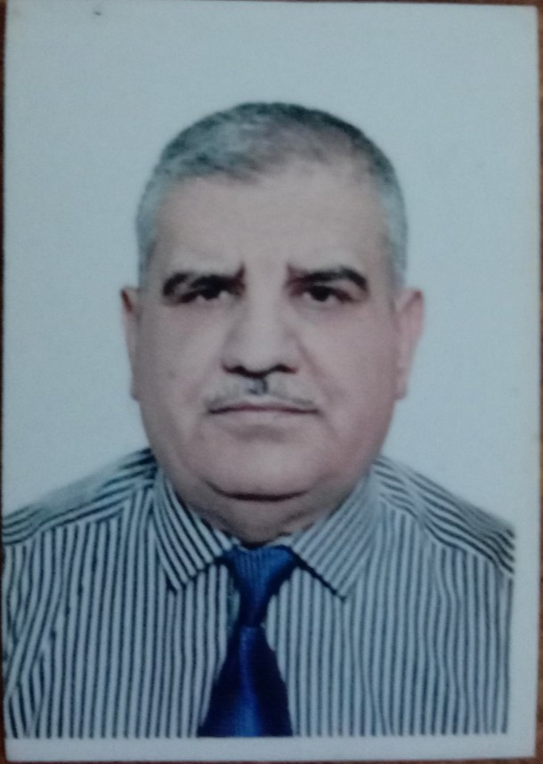
Name |  | Ahmed Yahya Abdullah
Nationality |  | Iraqi
Date of Birth |  | 10 / 2 /1957
Place of Birth |  | Duhok –Zakho |  |  |  |  |  |  | Marital Status | Married
Contact Information
E-mail |  |  | Ahmed.abdulla@uod.ac |  |  |  |  |  | E-mail
Home Address  (Permanent Address) |  |  | Duhok / Grebas |  |  |  |  |  | Mobile No. |  | 00964 07503127044
Education
Degree |  |  |  | Bachelor |  |  | Master |  |  |  |  | Scientific Title
University Name |  |  |  | AL- Mustansriya |  |  | Baghdad |  |  |  |  | Lecturer
Country |  |  |  | Iraq |  |  | Iraq
Date of obtaining degree (Day/Month/Year) |  |  |  | 28/6/1980 |  |  | 17/11/1986
Bachelor (Major /Specialization) |  |  |  |  |  |  | Accounting &Business Administration.
Master (Major / Specialization) |  |  |  |  |  |  | Accounting / Governmental Accounting .
Title of Master Thesis |  |  |  |  |  |  | Current governmental accounting system in Iraq toward the feasibility of its improvement.
Title of PhD. Dissertation

Experience in University of Duhok- Iraq
From  D/M/Y | To  D/M/Y |  |  |  |  | Position /Title |  |  |  |  |  |  | Nature of work
17/9/2007 | 8/3/2009 |  |  |  |  | Dean Assistant |  |  |  |  |  |  | Students Affairs
27/9/2009 | I was appointed as a department rapporteur several times |  |  |  |  | Department rapporteur |  |  |  |  |  |  | Department students affairs
Courses Taught
1- Intermediate accounting
2-Governmental accounting , .
3-accounting in English
4-financial analysis
5-accounting theory
6- advance accounting
7-money and banks
8- cost accounting I
9- international accounting
Activities
Scientific Research Published |  |  |  |  |  |  |  | Journal /Institution |  |  |  |  |  | No. and Volume/Year
1-Governmental financial reporting in Iraq: Reality and Obstacles field study of the Views of sample of Government Accountants and Auditors in the Supreme Audit Board |  |  |  |  |  |  |  | Tanmiat Al- Rafidain Journal university of Mosel |  |  |  |  |  | 102/33/2011
2-Evaluation of Local Government performance by using Card Performance Balanced / suggested Model |  |  |  |  |  |  |  | Journal of University of Duhok |  |  |  |  |  | 2 / 14 / 2011
3-Activating of CPA Firms performance in light of Quality control Systems and Its role in supporting of the financial Reform requirements / Field study in Iraq Environment |  |  |  |  |  |  |  | Journal of University of Duhok |  |  |  |  |  | 1/ 16 /2013
4-Financial and Planning Budgeting In Accounting Requirements For Application of the Programming & planning Budgeting in Kurdistan Region |  |  |  |  |  |  |  | Journal of university of Duhok |  |  |  |  |  | 1/18/ 2015
5- The Role of labor Market in Improving Quality of Accounting Education. Exploratory Search for a sample of Academics and Professionals in accounting area in Duhok Province . |  |  |  |  |  |  |  | Academic Journal of Nawroz University (AJNU) |  |  |  |  |  | 4/4/2018
6- Factors Impact on Audit Effectiveness: The Case of Duhok University in Kurdistan – Iraq |  |  |  |  |  |  |  | International Business and Accounting Research Journal |  |  |  |  |  | 2/7/2020
Conferences |  |  |  |  |  |  |  | University-City |  |  |  |  |  | Year
Subjects Teaching
Governmental Accounting
Computer Skills
Software / Program |  |  |  |  | Level
Microsoft Word, Microsoft power point, Internet |  |  |  |  | good
Language Skills
Language |  |  |  |  | Level
Kurdish and Arabic |  |  |  |  | Good
English |  |  |  |  | Good
Other

