Personal Information |  |  |  |  |  |  |  |  | 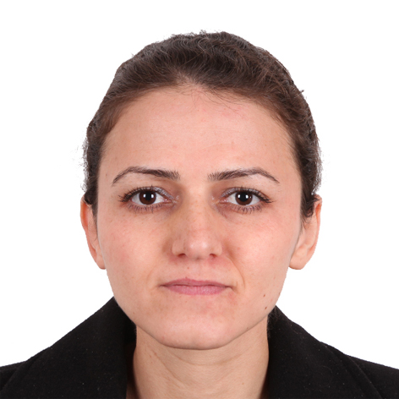
Name |  | Avan Safar Elias
Nationality |  | Iraqi
Date of Birth |  | 16\02\1983
Place of Birth |  | Alqosh |  |  |  |  |  |  | Marital Status | Married
Contact Information
E-mail |  |  | avan.elias@uod.ac |  |  |  |  |  | E-mail |  | @uod.ac
Home Address  (Permanent Address) |  |  | Dohuk, Avrocity, B41 |  |  |  |  |  | Mobile No. |  | 009647502026593
Education
Degree |  |  |  | Bachelor |  |  | Master |  |  |  |  | Scientific Title
University Name |  |  |  | Mosul |  |  | Mosul |  |  |  |  | Assistant Lecturer
Country |  |  |  | Iraq |  |  | Iraq
Date of obtaining degree (Day/Month/Year) |  |  |  | 30\06\2005 |  |  | 09\07\2008
Bachelor (Major /Specialization) |  |  |  |  |  |  | Statistics
Master (Major / Specialization) |  |  |  |  |  |  | Applied Statistics
Title of Master Thesis |  |  |  |  |  |  | Using Tukey’s transformation in Response Surface Methodology with application
Title of PhD. Dissertation |  |  |  |  |  |  | Using Fisher information approach in nonlinear dynamical systems
Experience in University of Duhok- Iraq
From  D/M/Y | To  D/M/Y |  |  |  |  | Position /Title |  |  |  |  |  |  | Nature of work
25/10/2011 | 04\2012 |  |  |  |  | مقرر قسم الأحصاء/جامعة دهوك/كلية الأدارة والأقتصاد |  |  |  |  |  |  | administration
Courses Taught
Principles of Statistics
Differential Equations
Sampling
Design and Analysis of Experiments
Design and Analysis of Experiments \ Master
Nonparametric methods
Decision theory
Operation Research
Principles of Mathematics
Activities
Scientific Research Published |  |  |  |  |  |  |  | Journal /Institution |  |  |  |  |  | No. and Volume/Year
Sustainable theory of a logistic model- Fisher information approach |  |  |  |  |  |  |  | Mathematical Biosciences |  |  |  |  |  | Volume 285, March 2017, Pages 81-91
Conferences |  |  |  |  |  |  |  | University-City |  |  |  |  |  | Year
23rd -26th July 2018 |  |  |  |  |  |  |  | Presenting seminar |  |  |  |  |  | Young Researchers in Mathematics (YRM) 2018, University of Southampton, UK
26th -29th March 2018 |  |  |  |  |  |  |  | Presenting seminar |  |  |  |  |  | BAMC 2018 conference,  University of St. Andrews, UK
17th-18thAugust  2017 |  |  |  |  |  |  |  | Presenting seminar |  |  |  |  |  | ICAMNA 2017, Denmark
13th -16th February 2017 |  |  |  |  |  |  |  | Attendance |  |  |  |  |  | Writing programme ``laying the foundations for effective writing’’, University of Sheffield, UK
1st -4th August 2016 |  |  |  |  |  |  |  | Presenting seminar |  |  |  |  |  | Young Researchers in  Mathematics (YRM2016), University of St. Andrews, UK
18th April 2016 |  |  |  |  |  |  |  | Presenting seminar |  |  |  |  |  | SoMaS PGR, University of Sheffield, UK
25th -28th Jan 2016 |  |  |  |  |  |  |  | Attendance |  |  |  |  |  | Intensive training programme ``laying the foundations for effective writing’’, University of Sheffield, UK
13th Jan 2016 |  |  |  |  |  |  |  | Attendance |  |  |  |  |  | Machine Learning with MATLAB, MathWorks, University of Sheffield, UK
12th Jan 2016 |  |  |  |  |  |  |  | Attendance |  |  |  |  |  | Parallel Computing with MATLAB, MathWorks, University of Sheffield, UK
30 March-2 April 2015 |  |  |  |  |  |  |  | Presenting seminar |  |  |  |  |  | BMC-BAMC 2015  Conference, University of Cambridge, UK
2009 |  |  |  |  |  |  |  | Attendance |  |  |  |  |  | Teaching methods at Cultural and Social Centre, University of Duhok, Kurdistan Region, Iraq
Subjects Teaching
Computer Skills
Software / Program |  |  |  |  | Level
Language Skills
Language |  |  |  |  | Level
Kurdish and Arabic |  |  |  |  | Arabic Perfect
English |  |  |  |  | Very good
Other |  |  |  |  | Aramic

