Personal Information |  |  |  |  |  |  |  | 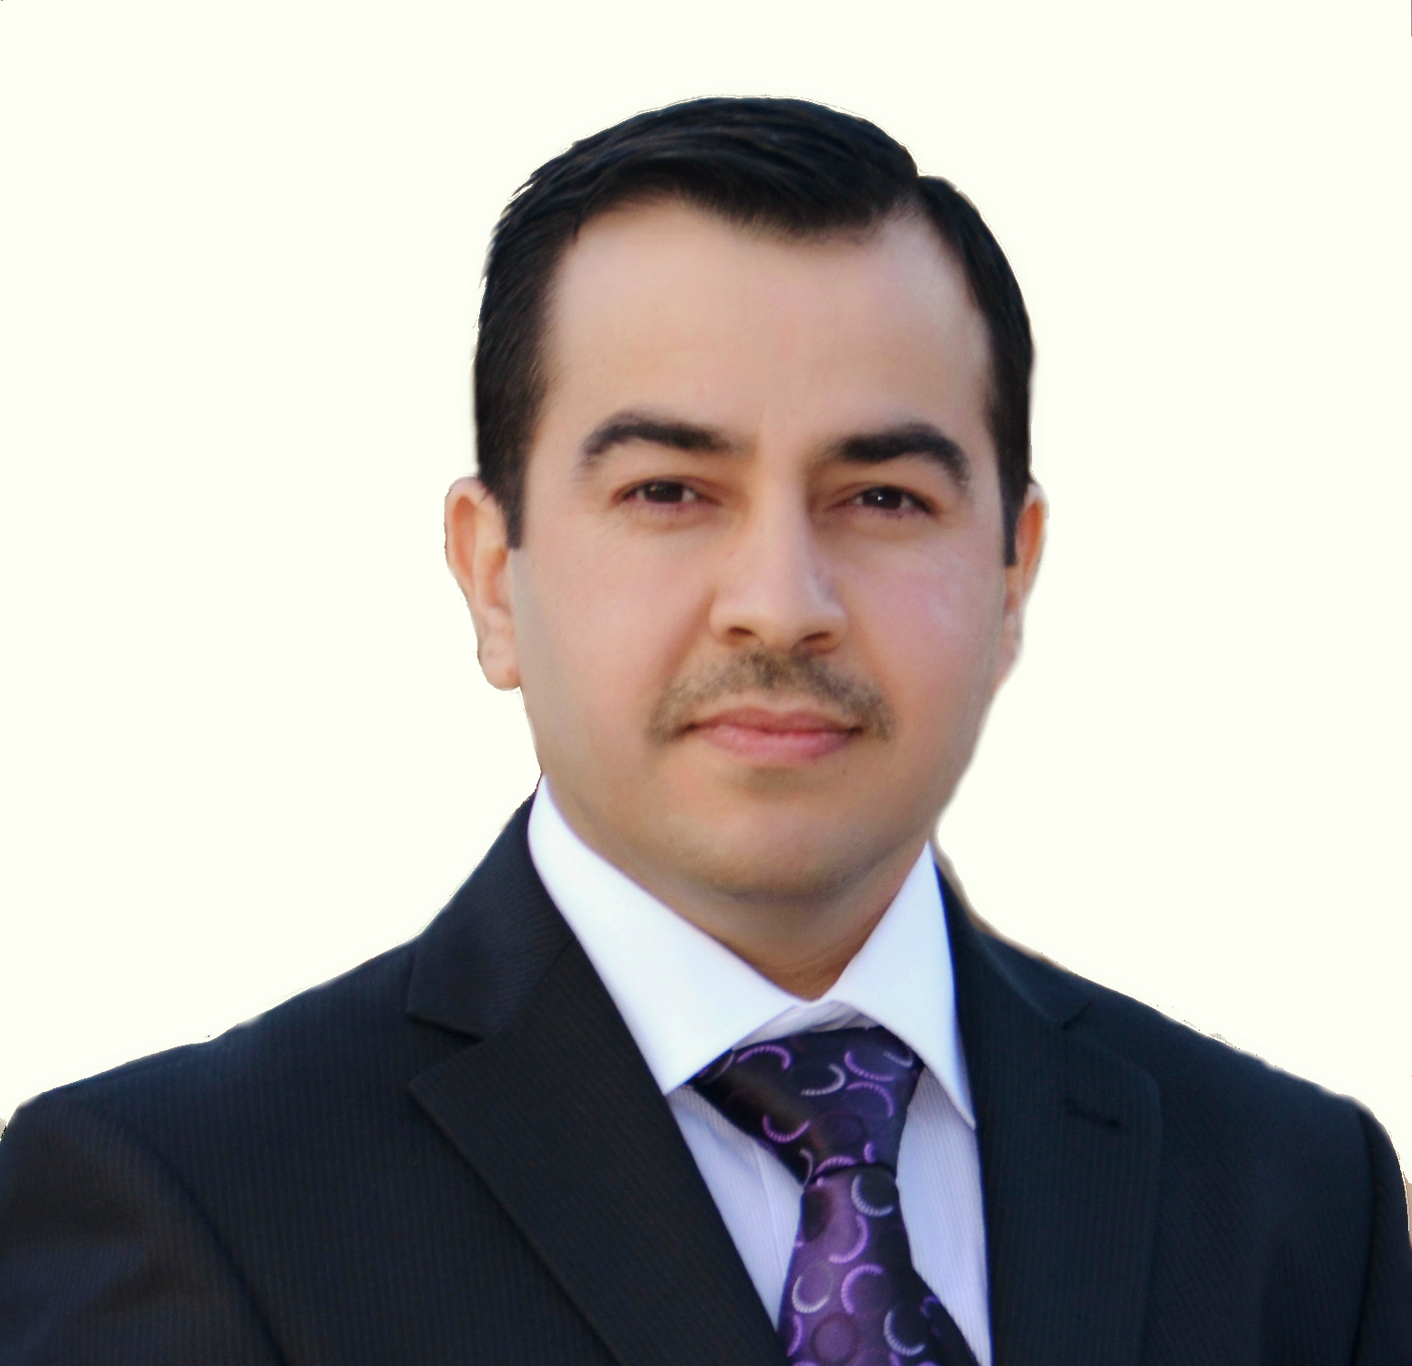
Name |  |  | Ziad Tariq Shukri
Nationality |  |  | Iraqi
Date of Birth |  |  | 9-5-1979
Place of Birth |  |  | Mosul |  |  |  |  | Marital Status | Married
Contact Information
E-mail |  | Zeadaqrwi79@gmai.com |  |  |  |  |  | E-mail |  | Zeyad.shukri@uod.ac
Home Address  (Permanent Address) |  | Dohuk, Avrosti |  |  |  |  |  | Mobile No. |  | 009647507637361
Education
Degree |  |  |  | Bachelor |  |  | Master |  |  |  | Scientific Title
University Name |  |  |  | Al-Hadba University College |  |  | College of Administration and Economics |  |  |  | Assistant Professor
Country |  |  |  | Iraq |  |  | Iraq
Date of obtaining degree (Day/Month/Year) |  |  |  | 2015 |  |  | 19/2/2019
Bachelor (Major /Specialization) |  |  |  |  |  |  | Banking and Financial Sciences
Master (Major / Specialization) |  |  |  |  |  |  | Banking and Financial Sciences/Financial management
Title of Master Thesis |  |  |  |  |  |  | The role of investment funds in the stability of financial markets: A study on a sample of Arab financial markets
Title of PhD. Dissertation |  |  |  |  |  |  | Strategies for building an efficient portfolio in the digital environment using quadratic programming
Experience in University of Duhok- Iraq
From  D/M/Y | To  D/M/Y |  |  |  |  | Position /Title |  |  |  |  |  | Nature of work
7/1/2010 | Now |  |  |  |  | University teacher |  |  |  |  |  | teaching
Courses Taught
I was studying tax legislation from 2010 to 2017
in addition to the subject of financial markets from 2012 until now.
Activities
Scientific Research Published |  |  |  |  |  |  |  | Journal /Institution |  |  |  |  | No. and Volume/Year
Studying the impact of knowledge and information network bases on developing the quality of banking services. |  |  |  |  |  |  |  | Koya University Magazine |  |  |  |  | 2014
Analyzing the relationship between each of the factors of fiscal policy and monetary policy on the market value of the Iraqi banking sector. |  |  |  |  |  |  |  | Erbil Polytechnic Magazine |  |  |  |  | 2015
The role of the investment portfolio in managing the risk of securities in light of Markowitz’s theory (analytical study on a sample of companies listed in the Iraq Stock Exchange). |  |  |  |  |  |  |  | Erbil Polytechnic Magazine |  |  |  |  | 2015
Analysis of the relationship between oil revenues and the market value of shares - an analytical study of the reality of the Saudi financial market for the period 1985-2012. |  |  |  |  |  |  |  | Dohuk University Journal |  |  |  |  | 2016
The currency auction of the Central Bank of Iraq and its role in achieving the stability of the exchange rates of the Iraqi dinar, an analytical study for the period from January 2010 to December 2012. |  |  |  |  |  |  |  | Nowruz University Magazine |  |  |  |  | 2017
Studying the trends of the general index for a sample of the financial markets in the Gulf countries using Japanese candles for the period from 1/6/2016 to 1/9/2016. |  |  |  |  |  |  |  | Nowruz University Magazine |  |  |  |  | 2017
The effect of exchange rate changes on global financial market indicators. |  |  |  |  |  |  |  | Dohuk University Journal |  |  |  |  | 2019
Opportunities to achieve capital gains from cryptocurrencies compared to other financial investments an analytical comparative study between Bitcoin and the shares of selected international companies. |  |  |  |  |  |  |  | Nowruz University Magazine |  |  |  |  | 2021
Conferences |  |  |  |  |  |  |  | University-City |  |  |  |  | Year
The FourthInternationalScientificConference at Nowruz University  (The extent of the effectiveness of indirect investment in financing direct investment in the Kurdistan region by activating the Erbil Stock Exchange) |  |  |  |  |  |  |  | Universityof Nowruz - Duhok |  |  |  |  | 2017
Subjects Teaching
financial markets
Computer Skills
Software / Program |  |  |  |  | Level
Office programs |  |  |  |  | very good
spss |  |  |  |  | very good
Eviews |  |  |  |  | Good
Minitab |  |  |  |  | very good
Language Skills
Language |  |  |  |  | Level
Kurdish and Arabic |  |  |  |  | very good
English |  |  |  |  | Good
Other

