Personal Information |  |  |  |  |  |  |  |  | Photo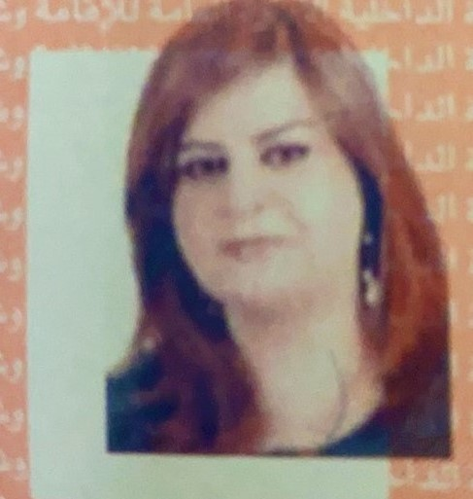
Name |  | ViyanTaha Mohammed
Nationality |  | Iraqi
Date of Birth |  | 19-09-1979
Place of Birth |  | Duhok |  |  |  |  |  |  | Marital Status | Married with two children
Contact Information
E-mail |  |  | Barwaryviyan362@gmail.com |  |  |  |  |  | E-mail |  | Viyan.taha@uod.ac
Home Address  (Permanent Address) |  |  | Duhok-French Village |  |  |  |  |  | Mobile No. |  | 009647504976351
Education
Degree |  |  |  | Bachelor |  |  | Master |  |  |  |  | Scientific Title
University Name |  |  |  | Dohuk University |  |  | Dohuk University |  |  |  |  | Instructor
Country |  |  |  | Iraq |  |  | Iraq
Date of obtaining degree (Day/Month/Year) |  |  |  | 2003 |  |  | 2010
Bachelor (Major /Specialization) |  |  |  |  |  |  | Economics
Master (Major / Specialization) |  |  |  |  |  |  | Finance and Banking
Title of Master Thesis |  |  |  |  |  |  | The banking systems in developing countries during 1990-2007 period
Title of PhD. Dissertation

Experience in University of Duhok- Iraq
From  D/M/Y | To  D/M/Y |  |  |  |  | Position /Title |  |  |  |  |  |  | Nature of work
2003 | 2007 |  |  |  |  | Assistant |  |  |  |  |  |  | Administrative duties at the department
2007 | 2010 |  |  |  |  | Master degree education
2010 | Until now |  |  |  |  | instructor |  |  |  |  |  |  | Teaching and research
Courses Taught
2017 Research methods ريكيت فه كولينى طرق البحث العلمي
2018 Business mathematics بيركاريا دارايى رياضيات مالية
2019 Scientific Discussions كه نكه شيت زانستى نقاشات علمية
2020 Economics ده ست بكيت ئابوورى مبادئ الاقتصاد
2021 Economics ده ست بكيت ئابوورى مبادئ الاقتصاد
Activities
Scientific Research Published |  |  |  |  |  |  |  | Journal /Institution |  |  |  |  |  | No. and Volume/Year
Portfolio Diversification Benefits Between the US and China (2021), forthcoming. |  |  |  |  |  |  |  | EconomiaInnazionale/ International Economics |  |  |  |  |  | http://www.iei1946.it/it/index.php
Conferences |  |  |  |  |  |  |  | University-City |  |  |  |  |  | Year
Subjects Teaching
Computer Skills
Software / Program |  |  |  |  | Level
MS-Word and MS-Excel |  |  |  |  | Very Good
Language Skills
Language |  |  |  |  | Level
Kurdish and Arabic |  |  |  |  | Excellent in both
English |  |  |  |  | good
Other

