Personal Information |  |  |  |  |  |  |  |  | p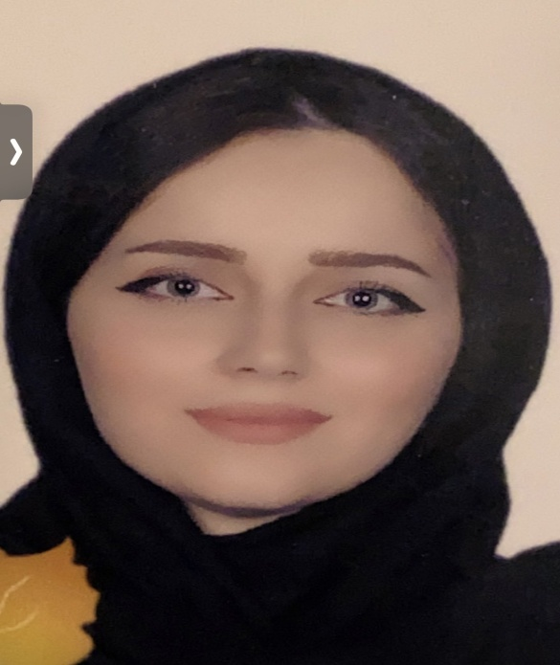hoto
Name |  | Payman mamoon nooruldeen
Nationality |  | Iraq
Date of Birth |  | 11/4/1986
Place of Birth |  | duhok |  |  |  |  |  |  | Marital Status | Married
Contact Information
E-mail |  |  | Payman.noruldeen@uod.ac |  |  |  |  |  | E-mail |  | Payman.noruldeen@uod.ac
Home Address  (Permanent Address) |  |  | Duhok.cayar city |  |  |  |  |  | Mobile No. |  | 0096407504710924
Education
Degree |  |  |  | Bachelor |  |  | Master |  |  |  |  | Scientific Title
University Name |  |  |  | Duhok |  |  | Duhok |  |  |  |  | teacher
Country |  |  |  | iraq |  |  | iraq
Date of obtaining degree (Day/Month/Year) |  |  |  | 18/7/2007 |  |  | 14/1/2012
Bachelor (Major /Specialization) |  |  |  |  |  |  | Banking and Finance
Master (Major / Specialization) |  |  |  |  |  |  | Investment management
Title of Master Thesis |  |  |  |  |  |  | The impact of some financial policy tools on foreign direct investment in selected developing countries for the period (1990-2008
Title of PhD. Dissertation

Experience in University of Duhok- Iraq
From  D/M/Y | To  D/M/Y |  |  |  |  | Position /Title |  |  |  |  |  |  | Nature of work
2012 | 2021 |  |  |  |  | Teacher
Courses Taught
Activities
Scientific Research Published |  |  |  |  |  |  |  | Journal /Institution |  |  |  |  |  | No. and Volume/Year
The Role of The Moral Dimensions of The Financial Crisis in Strengthening Foreign Direct Investment in The Framework of Investment Indicators Fulfillment |  |  |  |  |  |  |  | The journal of duhok university |  |  |  |  |  | 2019
The Repercussions of The General Budget on The Investment Activity in The Kurdistan Region - Iraq for The Period (2006-2013) |  |  |  |  |  |  |  | The journal of duhok university |  |  |  |  |  | 2018
Conferences |  |  |  |  |  |  |  | University-City |  |  |  |  |  | Year
Subjects Teaching
Cost sccounting , credit management , scientific discussion , investment management
Computer Skills
Software / Program |  |  |  |  | Level
Word exel p.p |  |  |  |  | Very good
Language Skills
Language |  |  |  |  | Level
Kurdish and Arabic |  |  |  |  | Very good
English |  |  |  |  | good
Other

