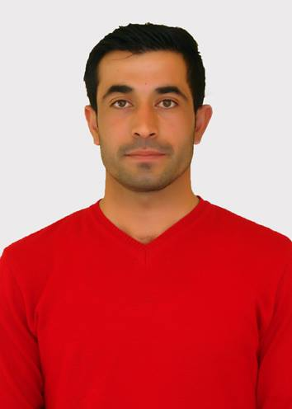

SHAWAF MUHAMMAD MUSTAFA

Contact info.
Birth date: 22, April, 1988,Akri, Iraq
Marital status: married
Email ( official ) : shawaf.Mahammed@uod.ac
Mobile: + 964 750 3518073
Address: Akri destrict, Postal Cod, 42004 Duhok, Kurdistan region, Iraq.

Personal profile
A highly motivated individual who is very honest, I have graduated with Bachelor of Art with the result of 1st class degree. I have under took many professional position after my graduation such as instructor in university where I was studding during my masters research. This job helped me to gain valuable experience and skills like communication skills. I have worked with people from different back ground hence this gave me better understanding people from different background. I’m result orientated individual with leadership style.

Education
- M.A: Master of education in psychological and educational sciene, resulting a thesis titled:” Measuring the Quality of life wellbeing among university employees in Erbil "" under supervision of Dr. Dasko E. Esmahel, Dr. Shawbo SH.Sulayman
, College of education, Department of psychological and educational sciene, University of Salahaddin, Erbil, Iraq, 2015-2017.
- B.A: Bachelor of education in psychological and educational sciene University of Salahaddin, Erbil, Iraq, 2010-2013.

Professional Duties

Duties in University of Salahaddin, Erbil, College of Education, Psychology department included:
- Office arrangement with the supervisor, Psychology Department, 2014 – 2015.
- Follow-up student’s attendance, Psychology Department, 2014 – 2015.
- Invigilator, exam process monitoring, Psychology Department, 2015 – 2016.
Language Skills

Language | Speaking | Reading | Writing
Kurdish (Bahdini and Sorani) | Excellent | Excellent | Excellent
English  Arabic | Modest  Basic | Modest  Basic | Modest  Basic

Skills and Expertise
- Time management for example meeting deadline & been punctual.
- Have gained excellent communication skills
- Working as part of successful team.
- Gained leadership skills.
- Computer applications such as: Microsoft group 2003-2013, SPSS.

Participations

- The participating at the Methods of Teaching course in Training & Development Center
- English Language Course, University of Salahaddin-Hawler , Language Centre, February 2014 – July 2014.

Certifications

- I have Methods of Teaching Certificate from Training & Development Center -University of Duhok
- I have English Language Course certificate, University of Salahaddin-Hawler, Language Centre, February 2014 – July 2014.
- I have Power point and Excel course certificate from Training & Development Center -University of Duhok, July 1 to 21, 2018.
- I have IELTS certificate from British Council in Erbil, December 16, 2018.
- I have English Language Course certificate at intermediate level, from center of language -University of Duhok, July29 to August 8, 2019.
- I have youth and future training Course certificate from Hujam Surchy Organization, Waar Organization, youth union, Women union and Bejeel student, August 28 to September 25, 2019.
- Scientific promotion and obtaining the scientific title of assistant lecturer issued by directorate of scientific affairs at University of Duhok according to administrative order no. 9683 on November 15,2019.

Educational Experience

- Instructor in College of Education, Psychology Department, 2014 – 2016.
- Instructor in College of Education,Akri, kurdish Department,University of Duhok. 2016 Up to now.
- lecturer in College of Education,Akri, biology Department,University of Duhok. 2017 Up to now.
- lecturer in College of Education,Akri, Islamic education Department, University of Duhok. 2017 Up to now.
- Assistant lecturer and teaching in University of Duhok, college of Education-Kurdish department, 2019 up to now.

Hobbies and Interests
Football, volleyball, swimming.

