Shayma Zuhair Ameen
25/09/2019
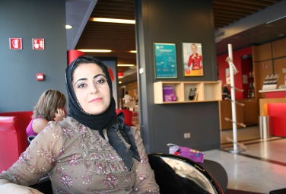 | Address : Dangeen street – Masika – Duhok – Kurdistan region – Iraq  Tel. No. : 00964 750 4739123  Email :Shayma.ameen@uod.ac  Birth day : 16/01/1980  Employed data : 31/12/2003 in college of veterinary medicine

Education

College of veterinary medicine – university of Duhok
B.Sc. in B.V.M.& S. with grade ( 74.768 degree ) on ( 20/07/2003 )
M.Sc. in veterinary medicine ( histological study ) ( 04/05/2008 )
86.6 degree

experience

teacher | college of veterinary medicine
08/03/2017 – till now
Teaching the second grade student in college of veterinary medicine both theory and practical of histology

reserches
- Morphological and histological studies of the Vomeronasal organ in male Karadi Sheep ( 15/12/2016 ) ( Basrah journal of Veterinary Research . No. 50/7/35m )
- Comparative histological and histochemical studies of the lacrimal glands of local sheep and goat ( 28/07/2016 ) ( Assuit Veterinary Midical Journal . Vol. 62 No. 150 )

Skills & Abilities
- Computer skill ( Microsoft word , excel , power point )
- Language { Kurdish ( mother language ) , Arabic and English }

Membership
Duhok Veterinary medicine Syndicate : ID no. 08196

References

Lokman Taib Berwary, Dean of college of veterinary medicine

