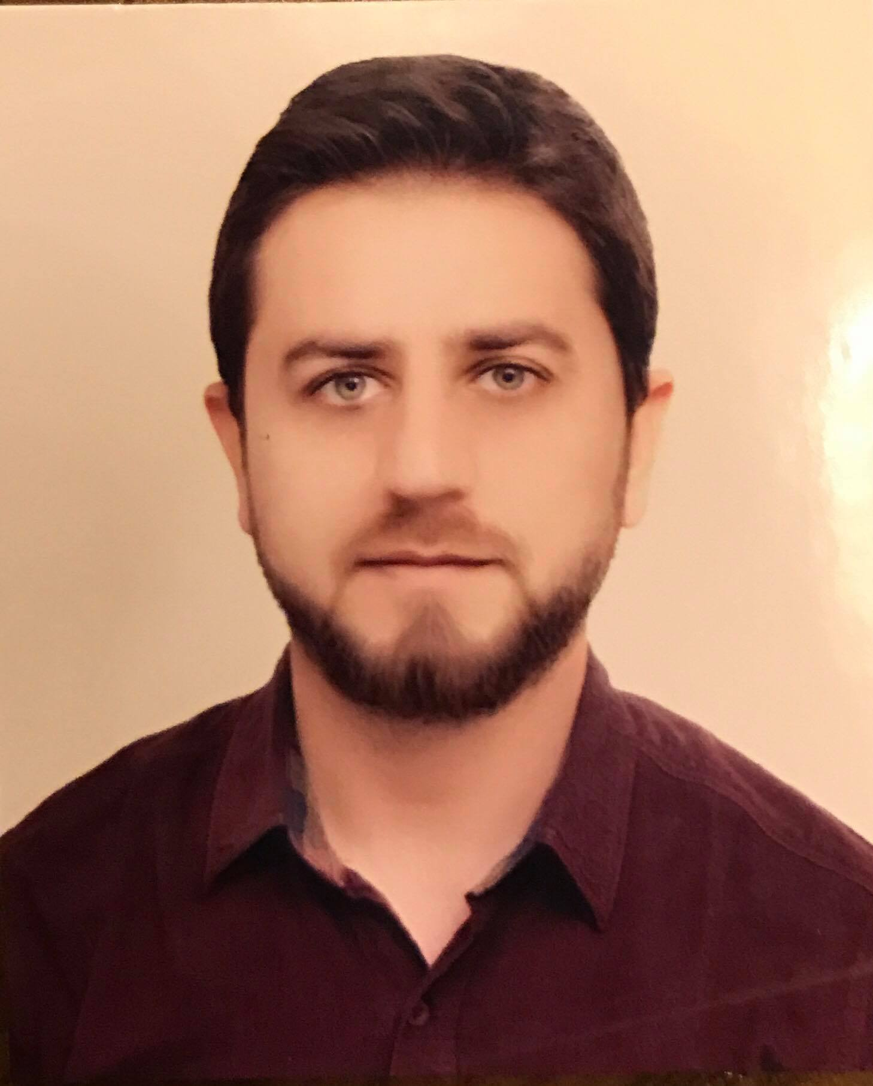
Curriculum Vita

Name: - Rahwan Waysi Haji
Gender: - Male
Age: - (Oct./10/1984)
Marital status : single
Email Address: - rahwanzebary@yahoo.com
Phone Number; - +9647504747915
Address;- Iraq- Kurdistan region – Duhok - Avrocity

Educational Qualifications

Hawler Medical University – College of Pharmacy (B.Sc – 2007)

Certificate in Pharmacovigilance (side effects of drugs) – WHO Erbil – 2010
Certificate in Application and characterization of (IR, C¹³ and H NMR , Mass and UV spectroscopy) in university of Baghdad 2012

Master in pharmacognosy 2012-2014.

Lecturer of pharmacology 2010-2017 in Akre poly-technical university / Nursing Department.

leturer of pharmacognosy 2015-2017 at university of Duhok college of pharmacy.

Work Experience
- Azadi teaching hospital – 2009
- Akre emergency hospital 2010-2011
- Health Directorate of Duhok 2014-2016
- Duhok eye hospital 2017

Trainings
Application of NMR and IR spectroscopy at Baghdad university .

Computer Skills
Microsoft Word, Excel, Power Point.
Internet Explorer

Language Skills
Kurdish (First Language)
English (Good)
Arabic (Good)

Personal Information

Hobbies: - Reading
Traveling to various parts of the world
Learning other languages
Learning culture and traditions of other countries.

Working Style:- quick adaptation, interested in working at a professional level, looking forward to work with companies and groups who put work and respect to their priorities.
Appreciation to my services encourages me to always give my best. Interesting of teaching at medical university

