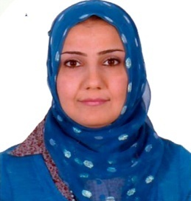
Lailan Taib
lailan.tayeb@uod.ac phone: 07504867224
Kurdistan region of Iraq
Duhok /Afro city
Education M.S in spatial planning 16/5/2012
Higher institute of planning
University of Duhok
Higher Diploma in spatial planning 1/9/2009
Higher institute of planning
University of Duhok
B.Sc in Agriculture 4/7/2000
College of Agriculture /plant production
University of Duhok

Skills Microsoft word, PowerPoint and GIS
Kurdish(mother language ), Arbic(Excellent ) and English language(good)
Relevant skill team work, teaching skill
Experience work in Liberia2000, registration Directorate and Administration Directorate 2004-2008 (collage of agriculture) work with FAO in 2000 for 10 days. In addition to teaching (sociological and ethnic relations 2014-2018, urban forestry2014-2018, ecotourism planning and development2017-2018 Kurdistan culture resources for ecotourism2017-2018 )
Activates International planning conference (challenges for urban development in Iraq) 3-5 /10/2010
2ndScintific Agriculture conference 26/4/2016
The Silver jubilee festival 24-26 /2018

