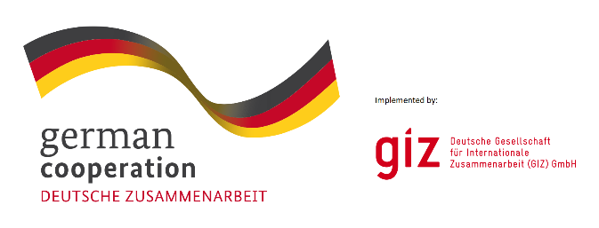

Consultancy Service for the Design of Sustainable Black Wastewater Treatment Plant in Dohuk governorate, Kurdistan Regional of Iraq (KRI)

By
Dr. Nashwan Shawkat Mahmood
PhD in Environmental and Sanitary Engineering
Civil Eng. Dept./University of Duhok

Document submitted to ACTED / Duhok / Iraq
2019

Executive Summary
Duhok city currently has not any Black wastewater treatment facilities. The trucks are disposing the sludge and black wastewater everywhere illegally subsequently effecting to the ground water and human’s health. Some dumping sites are close to Mosul dam that is used as water supply for the downstream area. Furthermore some other illegally dumping sites are in some farms specifically faecal sludge dumping that is affecting directly to human health.
Dr. Nashwan from University of Duhok worked as consultant and designer collaborating with directorate of municipalities, and ACTED organization to establish a new black wastewater treatment plant namely waste stabilization ponds based on an easily replicable and cost-effective treatment solution. In addition, the project will promote local capacity to manage and monitor such systems for greater long-term protection of ecosystems. Furthermore, the effluent water will be used for Restricted and Unrestricted Irrigation. Besides, the sludge can be used to strengthen the local economy, by providing a safe, efficient and high-quality fertilizer for the local farmer community in the region. The project is sponsored by GIZ organization.
The project will serve around 500,000 population including Duhok city, Faida, Domiz, Sharia sub-districts in addition to Domiz 1, Domiz 2, and Khanke camps. The area of the project has been divided to three lines, two will be used for the current project and one will be used for the future expansion. A series of ponds will be constructed on each line (2 anaerobic ponds, 1 facultative pond, and 1 maturation pond). The project will involve also an office for the administration and a warehouse for the sludge composting.

