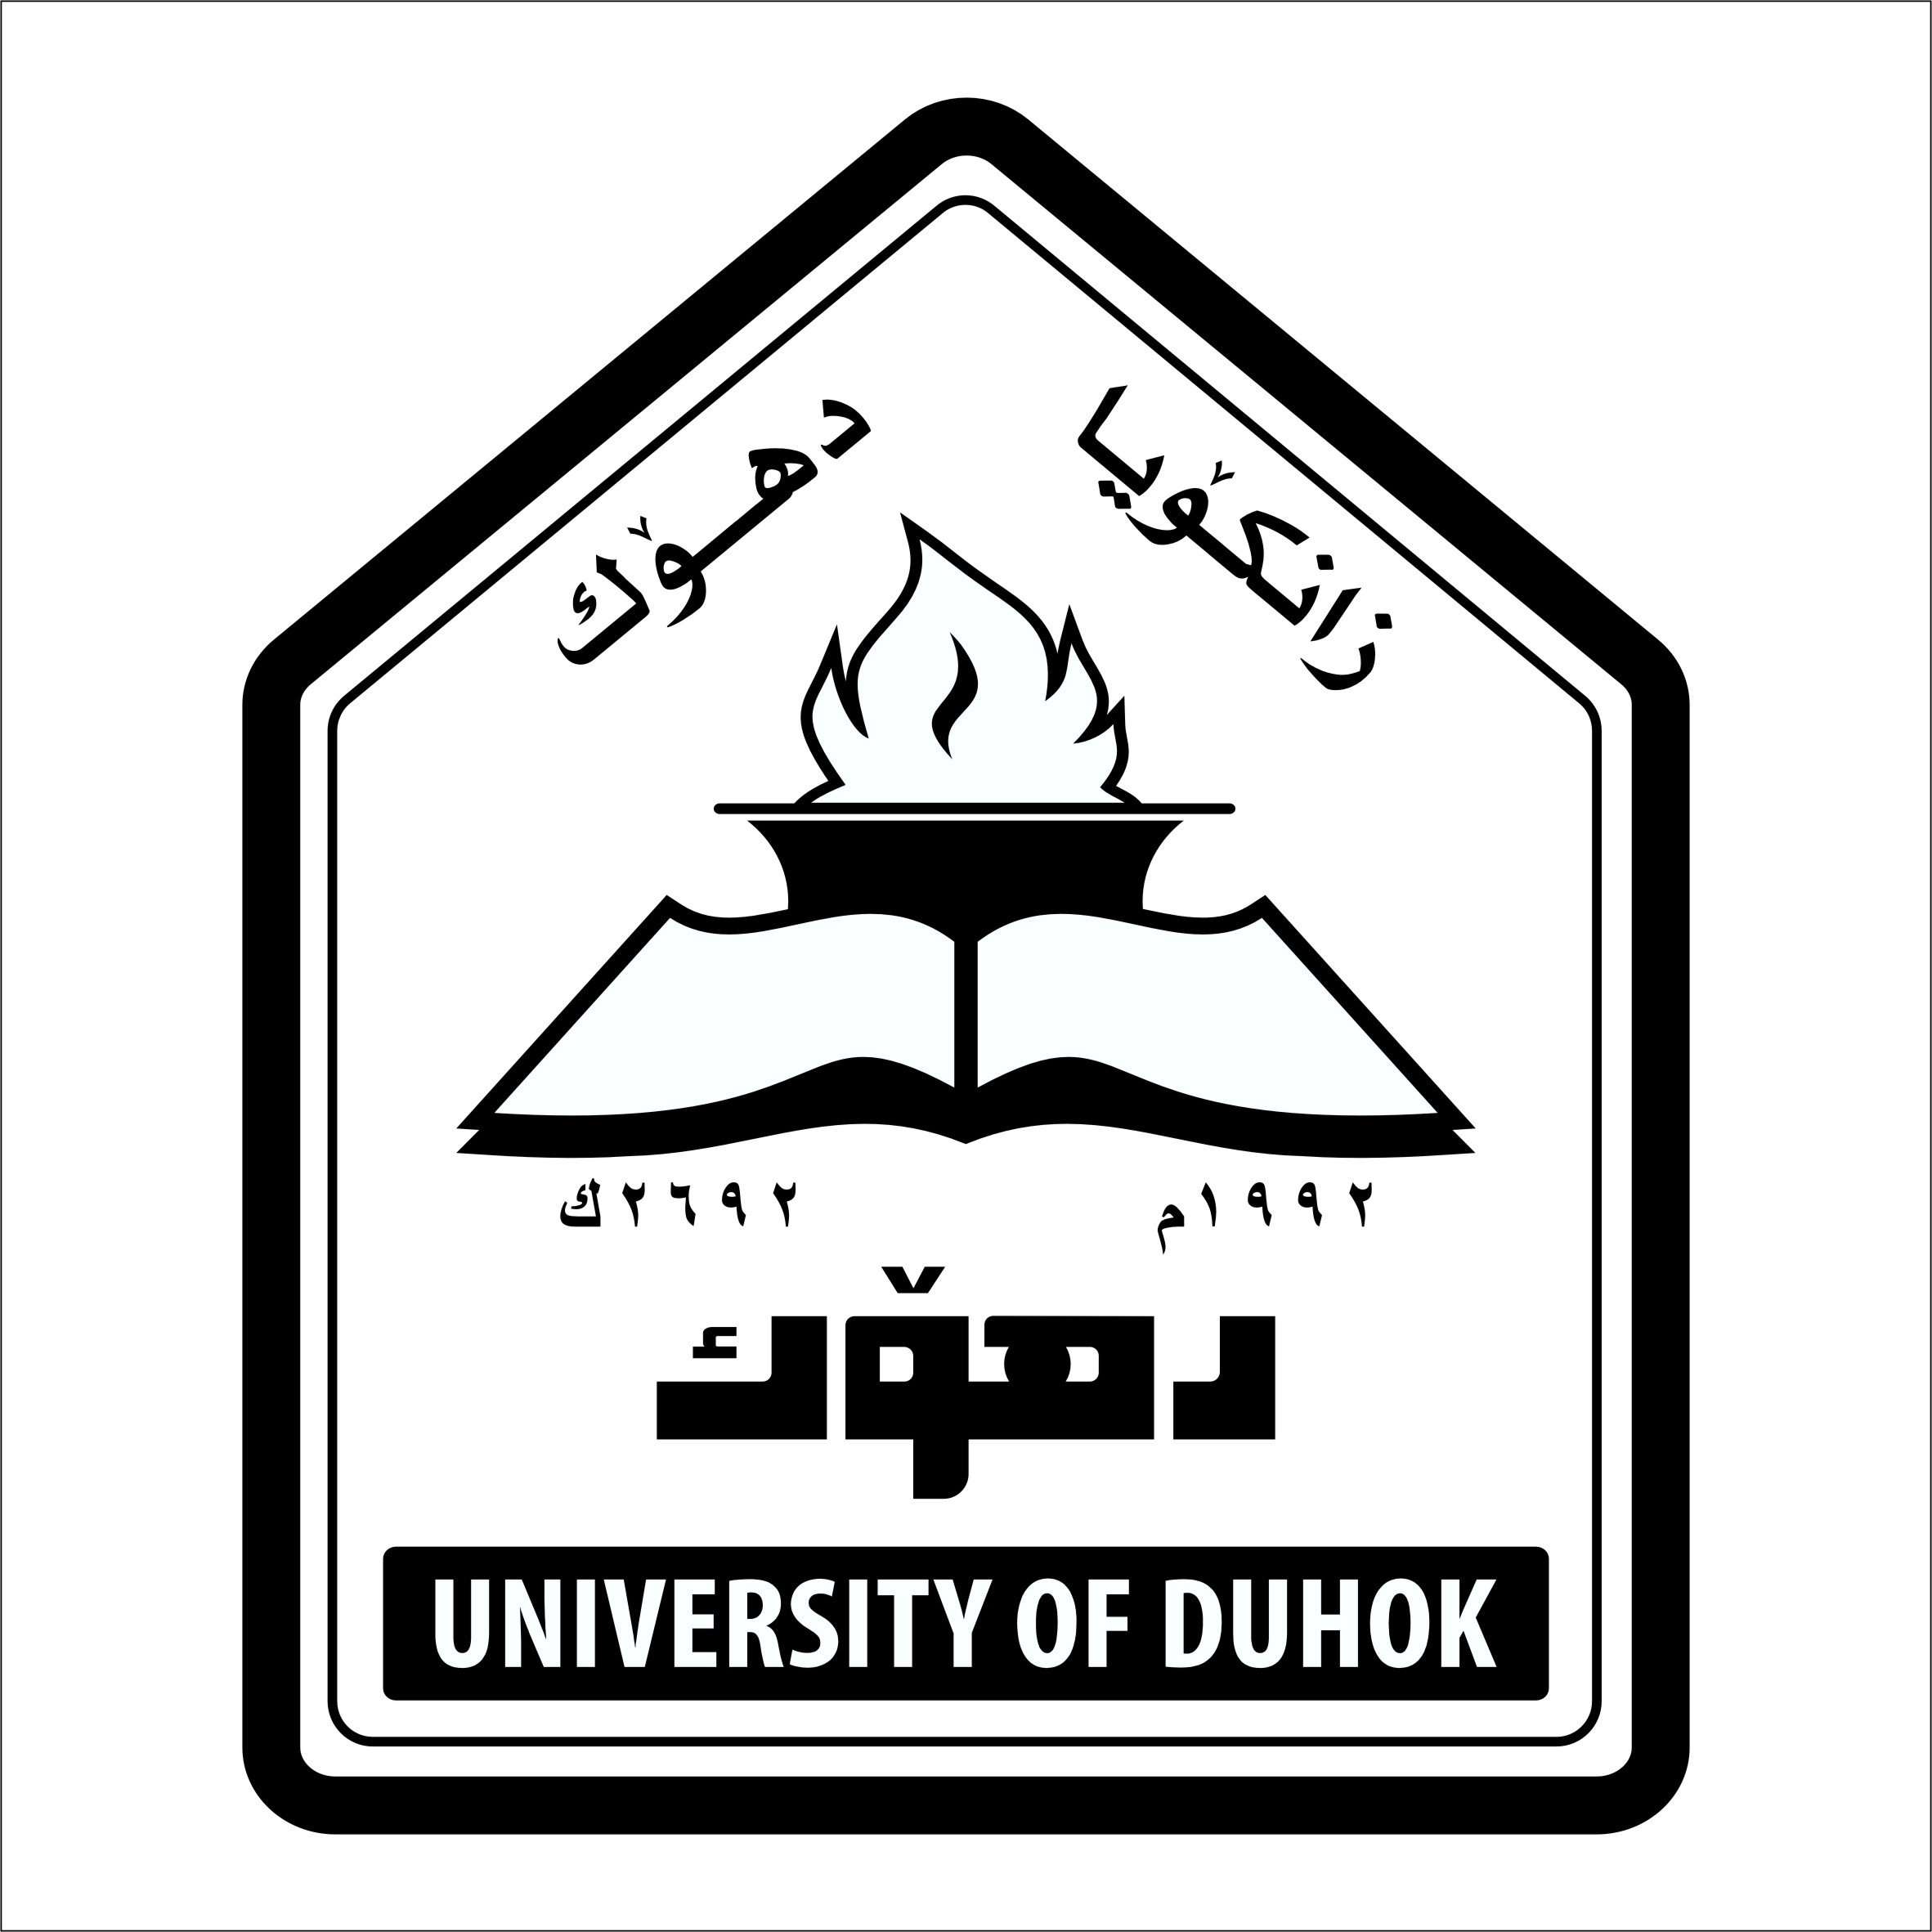
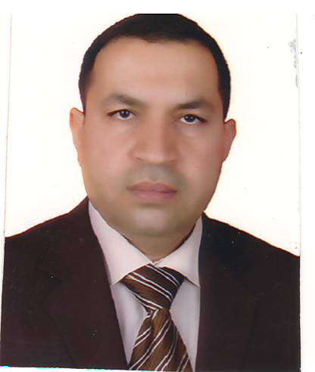
CURRICULUM VITAE
Name: Hashim Dawood Mousa
Scientific surname : Assistant Professor
Date of Birth : 1/7/1971 Erbil
Material Status : Married with two children
Wife : Suzan Mohammed Salih Taha
B.D.S (University of Mosul)
M.Sc. in Clinical Biochemistry(University of Dohuk)
Nationality: Iraqi
Languages: Kurdish , Arabic , English
Telephone / Mobile : 009647504711049
E mail : hashimdawood2007@yahoo.ca
hashim.mousa@uod.ca
QUALIFICATIONS
- B.D.S Mosul University, Iraq, 1995
- H.D. in Periodontics ,University of Sulaimany 2005
- M.Sc. in Periodontics, Hawler Medical University,2008
- Ph.D in Periodontics, Hawler Medical University, College of Dentistry from 2009 to 2013.

MEMBERSHIPS
- Members in Iraqi Dental Association since 1995
- Members in Kurdistan Dental Association since1996

SCIENTIFIC COURSES & DENTAL CONFERENCES
- Participation in most annual dental conferences of Iraqi dental association & college of dentistry in Iraq.
- Participation in training course of dental implantation in B&B system, duhok, 2008
- Participation in UAE international Dental Conference & Arab Dental Exhibition , AEEDC Dubai , 2009.
- Participation in the Second International Conferences of Medical Sciences ,Erbil, Iraqi Kurdistan , 2010.
- Participation in UAE international Dental Conference & Arab Dental Exhibition , AEEDC Dubai , 2012.
- Participation in training course of implantology , Duhok University, School of Dentistry, 2013.
- Participation in the first Scientific Meeting of Dentistry , Duhok Polytechnic University ,2014.
- Computer proficiency course in TDC/OOD.
- Certification in methods of teaching for higher education 2014.

EMPLOYMENT HISTORY
1995-1996 Duhok Specialized Dental Health Center (vocational training)
1996-2000 Duhok – Akra City Health Center (GDP- Akra Health Center)
2000-2002 Duhok – Duhok Health Center (GDP- Shoresh Health Center)
2003-2004 Duhok Specialized Dental Health Center (GDP)
2005-2006 High Diploma student . Sulaimany University.
2006- 2007 M.Sc student, Hawler Medical University.
2008-2009 Specialist in Periodontics in Duhok Specialized Dental Health Center.
2009- 2013 Ph.D. student, Hawler Medical University.
2013 – to date Lecturer in Periodontic Departments in School of Dentistry / Duhok University.
2014 - 2017 Head of Department of P.O.P,School of Dentistry, Faculty of Medical Sciences ,Duhok University.
2017 - Head of Department of periodontics and maxillofacial surgery,college of dentistry, Duhok University.
2000 – to date private clinic in Duhok City.

Thiesis and Publications:
- Guided tissue regeneration (laboratory thiesis ) in High Diploma
- The effect of different intervention methods on periodontal health in different socio-economic levels. M.Sc thesis.
- The effect of meloxicam gingival injection on the ingival of rabbits(histological, immunological & biochemical study) Ph.D. thesis.
- Effect of zinc supplementation on periodontal status
- Oral health status among Yezides in khanke camp.
- Can Periodontal therapy reduces the severity of active Rheumatoid Arthritis
- Prevalence of Periodontal Disease among Rheumatoid Arthritis patients
- Level of lipid in blood & it is relation to chronic periodontitis

Letters of Gratitude
- 2 letters of gratitude from general directorate of health in Duhok.
- 2 letters of gratitude from School of Dentistry, Faculty of Medical Sciences ,Duhok University.

