Project Report

Name of Project: sensitive issues of the community
Standing committee:SCORA
Date of Project: 24,25,26/7/2018
Place: DUHOK YOUTH CENTRE
Project Cost: zero
Project description: IFMSAmembers as a collaboration with Ypeer held a 3 days session where all the members with the ypeer trainers were discussing many sensitive issues of the community and most importantly Women's rights and gender equality, all types of violence, early marriage, leadership, anger management, harassment, addiction, and many other things the session was about discussing, giving opinions, presentations, funny activities with different points

Manager: Maawa Hussein

Name of members who participated:
Alaa Ahmed Hamdy
Dania Abdulsalam yaseen
Hanin majeed
Zubaida khalaf
Seelav Muhammed muhhamed_tahir
Juwan mohhamed ahmed
Non ifmsa memvers6:
Jeen nizar
Sara noori
Ihab mazin
Mustafa hamdy
Rami basam
Peeishan mahmod
Taha idrees

Number of people reached: 14

Feedback was done:
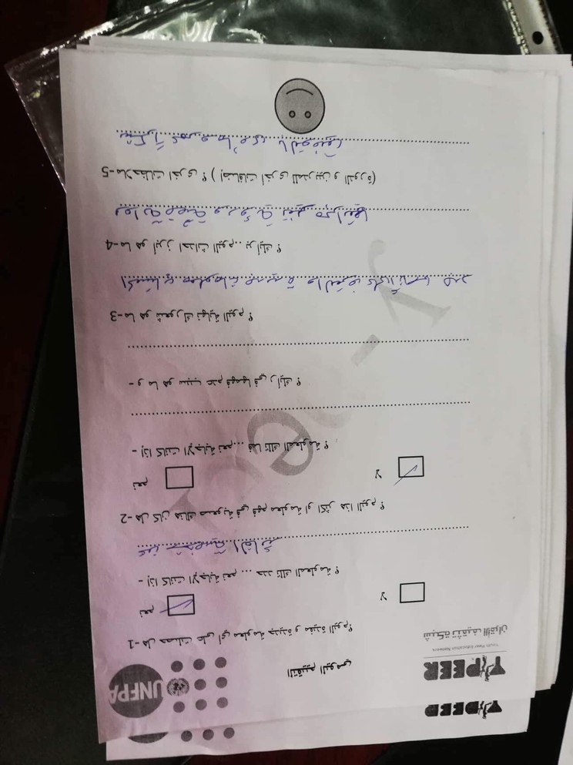
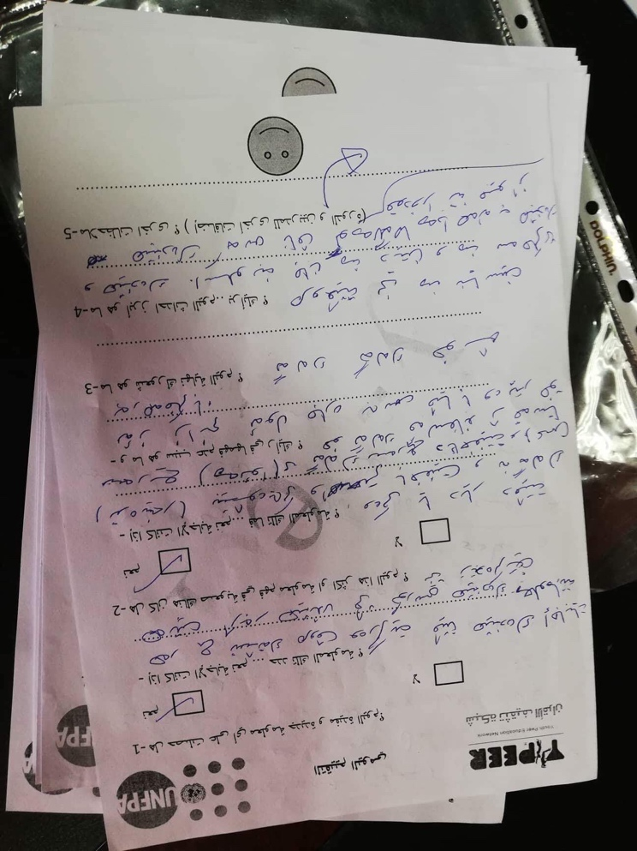

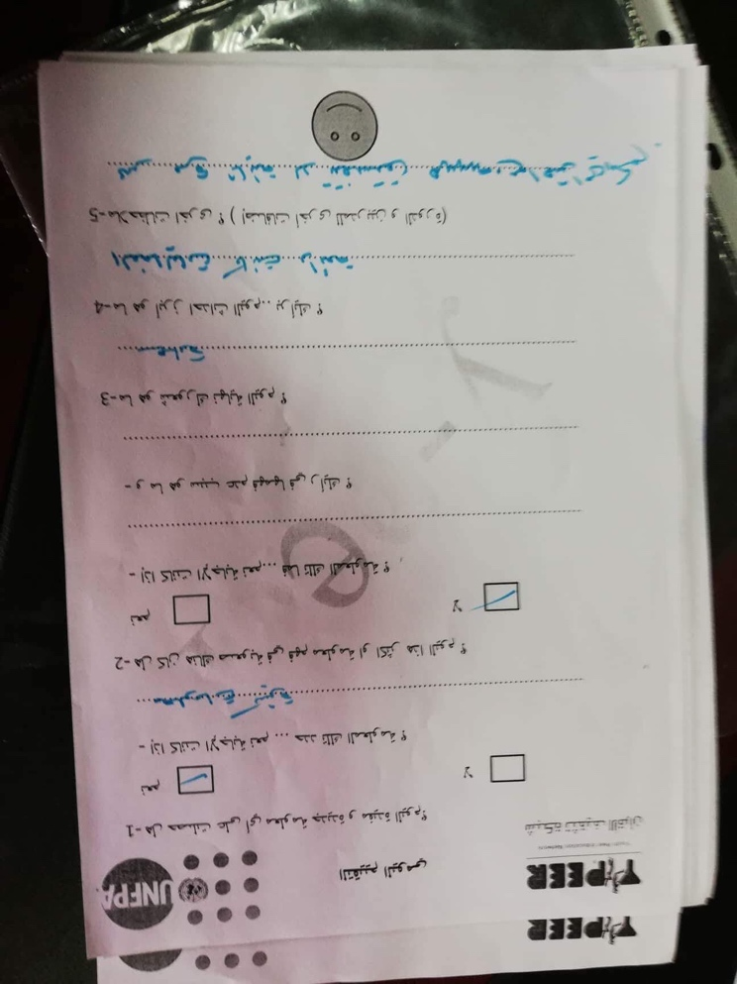
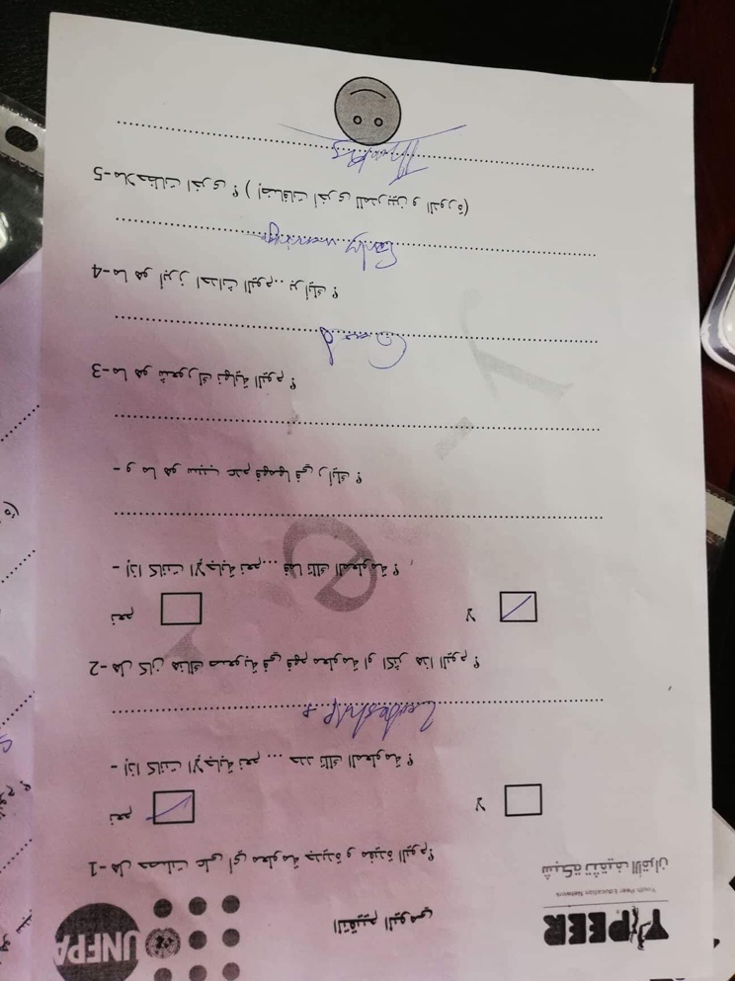

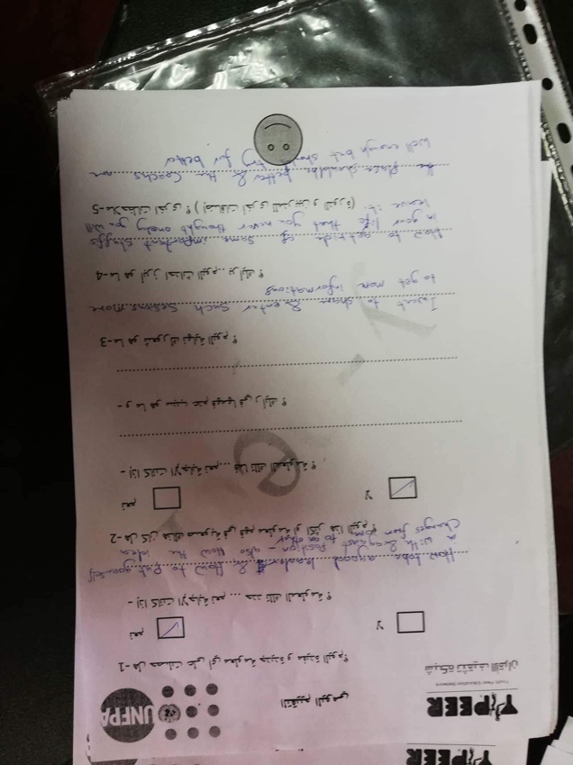
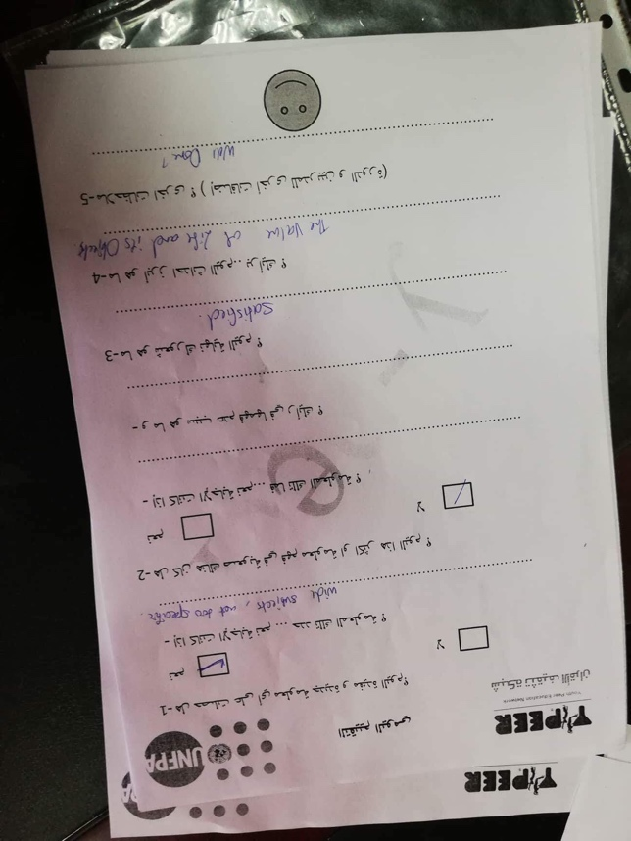

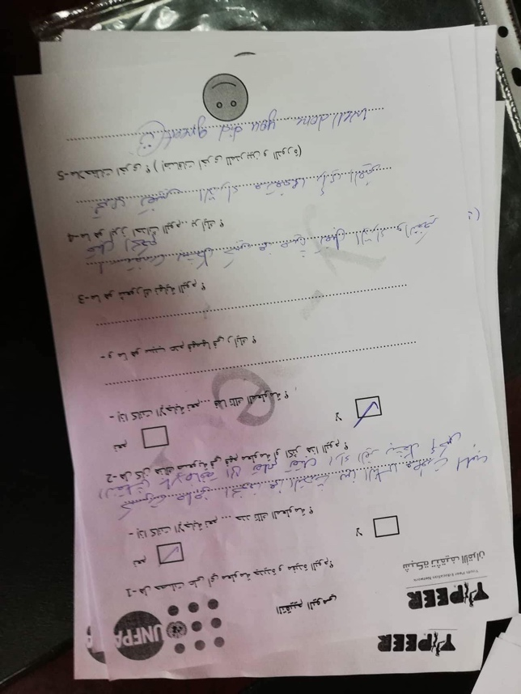
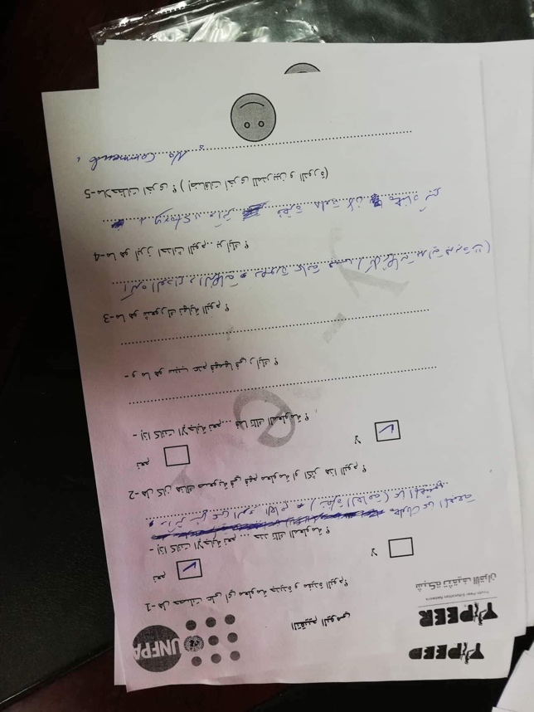

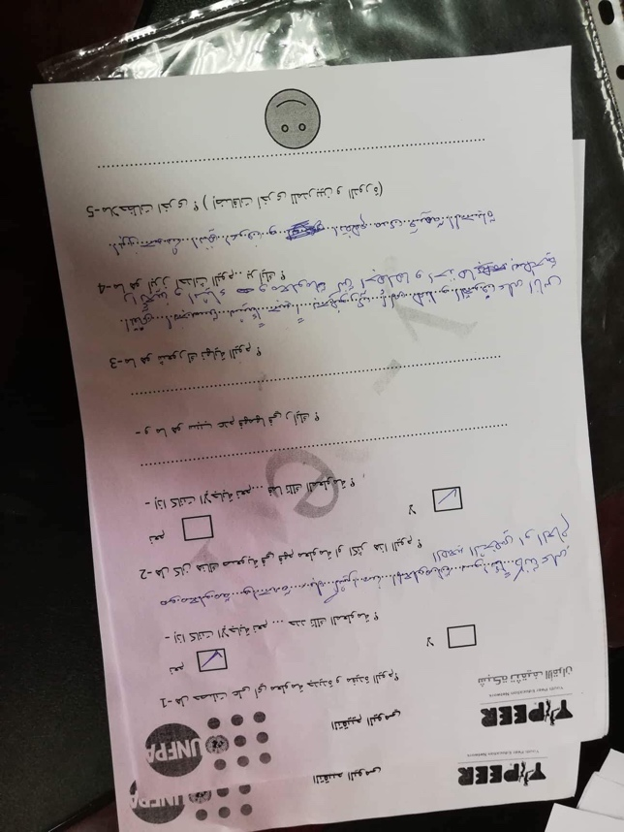
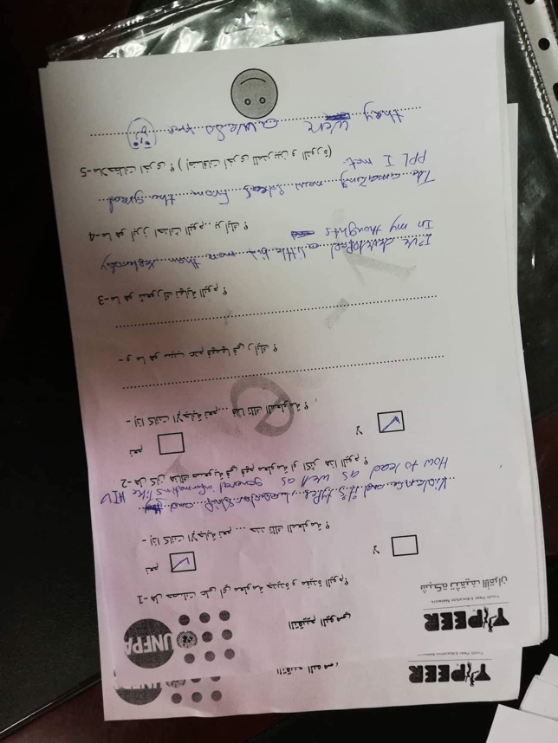

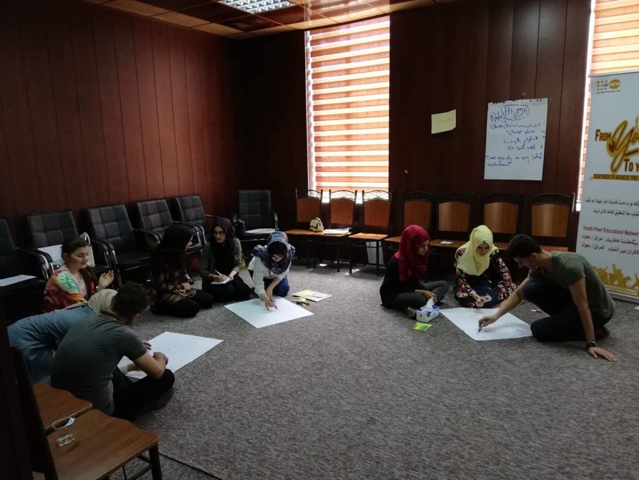
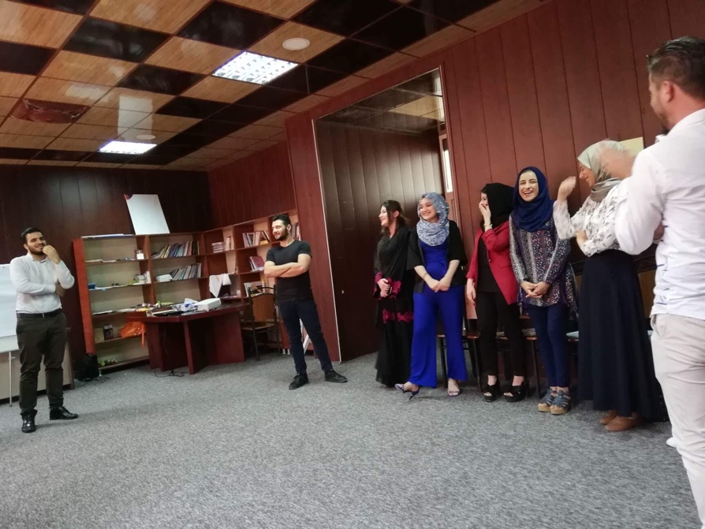
Pictures:
