Project Report

Name: breastfeeding awareness
Manager: Alaa Ahmed Hamdy
Assistant: Duaa Farhad
Place: Saeed piran hospital in Zaxo
Date: 14\Aug\2018
Description: our members tried to aware people about the benefits of breastfeeding for children and their mothers health as well by distributing leaflets and communicating with women to increase the awareness of this topic among the community.
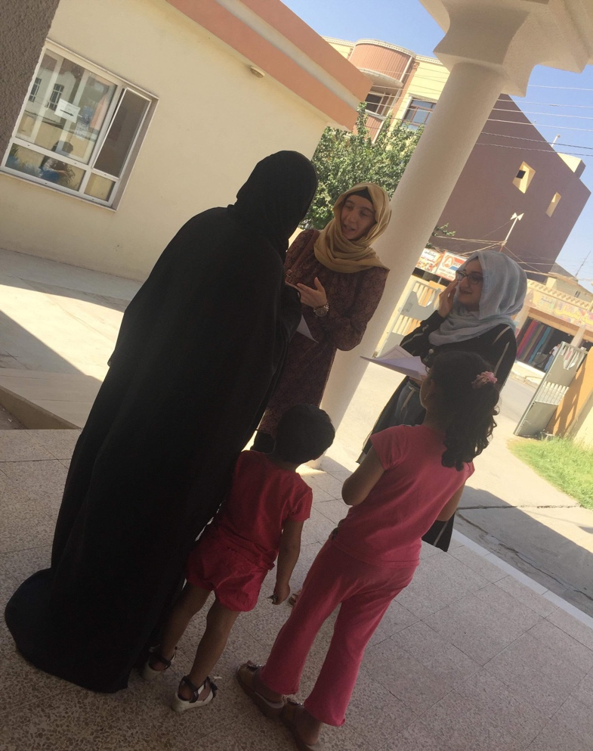
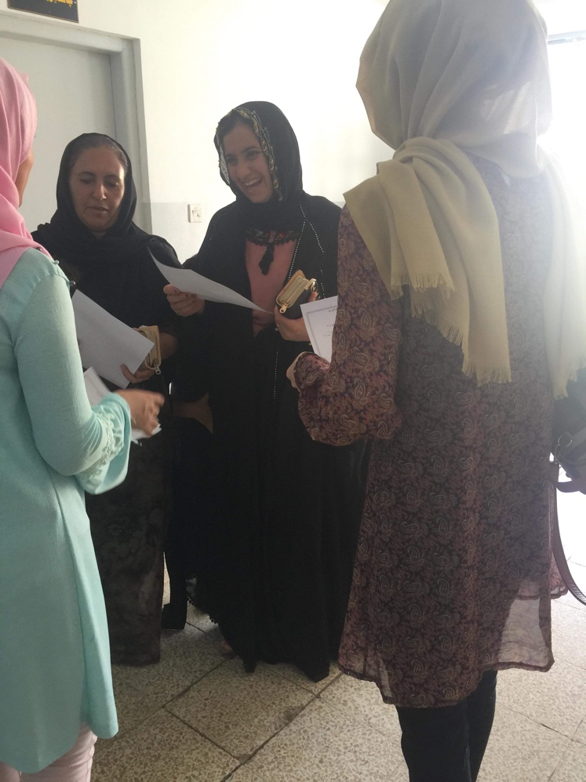
Members: Delman yousif Abdullah\candidate
Num of beneficiaries: 30

