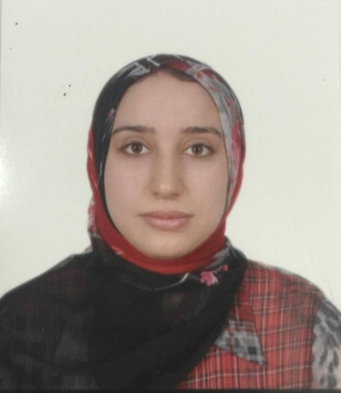

Halima mohammed Hassan
Address Kurdistane-Duhok
sherko36@yahoo.com
+9647504807264

Education

Bachelor of Dental Surgery– hawler medical university ; 2009

Career History

Rotator Doctor 2010-2012: specialized center of dentistry - Duhok

Researcher assistant 2012-current: University of Duhok College of dentistry- Duhok
Orthodontics dentistry 4th and 5th stage.

Training courses attended
2012 Preventive dental course
2013 Implant dental training -Duhok

Skills
Languages
Kurdish--Native
Arabic--Native fluency
English--Good fluency

