(Curriculum Vitae)
Curriculum vitae

Personal:
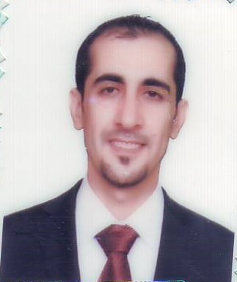
Name : AKRAM MAHMOOD ELIAS
Gender : Male
Date of birth : January, 18, 1984
Place of birth : Ninawa, IRAQ.
Present Address : Duhok, Iraq.
Marital Status : married
No. of children : one
Mobile phone no. : (+964) 07504401185
E-mail : edu_dent@yahoo .com
Education:
2010-2013 M.Sc. in Oral and Maxillofacial Surgery, College Of Dentistry, Hawler Medical University. Erbil - Iraq.
2001-2006 B.D.S in College Of Dentistry, University Of Mosul, Ninawa–Iraq.

Current research interests:
Dental implants with simultaneous sinus lift using different graft materials.
Research experience:
2010-2013 M.Sc. Thesis, Department Of Oral And Maxillofacial Surgery, College Of Dentistry , Hawler Medical University ,Erbil- Iraq
Teaching experience:
2013-2014 Assistant Lecturer At Department Of Oral Surgery ,college of Dentistry, University Of Duhok, Duhok - Iraq.
Languages:
1- Mother language: Kurdish + Arabic.

2- Other languages: English.

