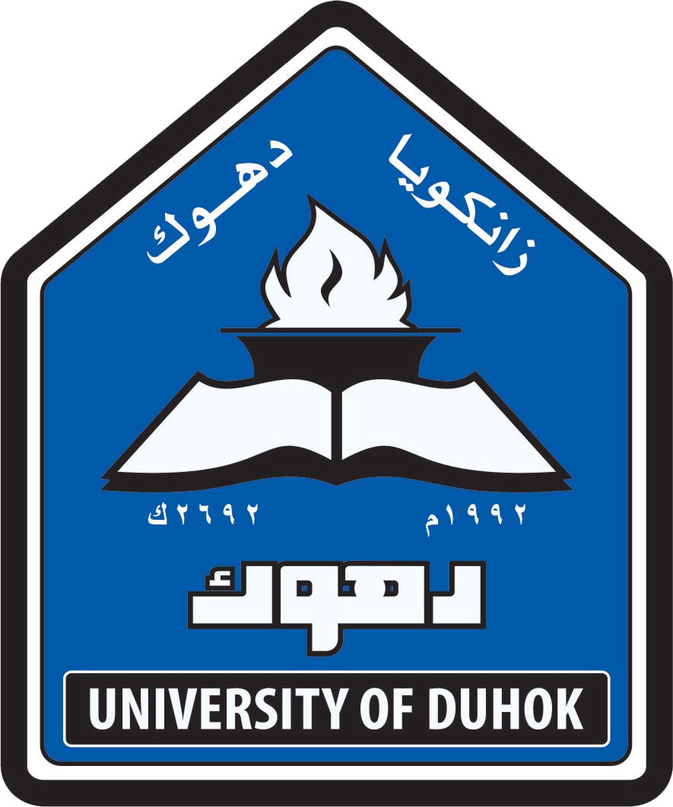
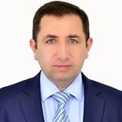
CURRICULUM VITA
Dr. Saeed Ali Mohammed Barwary
Name : Saeed Ali Mohammed Barwary
Date of birth: November 28th 1972
Marital Status: Married with three children
Nationality: Iraqi (Kurdistan Region)
Languages : Kurdish,Arabic and English
Telephone/mobile: 009647504577151
E mail: saeed.ali@uod.ac
QUALIFICATIONS
- B.D.S , College of Dentistry, Mosul University, Iraq 1995
- H.D, College of Dentistry, University of Sulaimany, Iraq 2005
- M.Sc. in Periodontics, College of Dentistry, Hawler Medical University 2008
- Ph.D in Periodontics, College of Dentistry, Hawler Medical University 2013
MEMBERSHIPS
- Member in Iraqi Dental Association (1995-to date)
- Member in Kurdistan Dental Association (1995-to date)
DENTAL CONFERENCES
1.Participation in most annual dental conferences of Iraqi dental association and Colleges of dentistry in Iraq.
2.Worked with Help Age International as a dentist for the period of June 1999 to March 2000.
3.The first and second International Conference of Medical Sciences,Erbil,Iraqi (Kurdistan Region) 2009-2010
4.Participation in Iraqi dental reunion 1st and 2nd conferences 2011-2012
5.Participation in Conference and Exhibitions of Aeedc-Dubai 2009-2012
6.First Dental Implantology Workshop,school of dentistry,Faculty of Medical Sciences,University of Duhok 2013
7.Second scientific national conference for Iraqi dental colleges,Baghdad 2013
8.First Scientific Meeting of Dentistry,Duhok Polytechnic University 2014
9.Training course on cosmetic dentistry by Tokuyama Company,Erbil,Iraq 2014
10.Participation in Conference and Exhibitions of Aeedc-Dubai 2015.

SCIENTIFIC COURSES

- Participation in the Course in Teaching Methodes for Higher Education,Methods of Teaching,Training and Development Center,University of Duhok 2013-2014

EMPLOYMENT HISTORY
1995 Duhok Specialized Dental Health Care Center (Rotatory training)
1996-1999 Duhok-Amedia City Health Center,Dental health care unit
2000-2003 Duhok Health director, KHabat Health Center,Dental health care unit (practitioner)
2003-2004 Duhok Health Director, Specialized Dental Health Care Center
2005 High Diploma student, College of Dentistry, University of Sulaimany
2006-2008 M.Sc student, College of Dentistry,Hawler Medical University
2008-2009 Specialist Dentist in periodontic Department in Duhok Specialized Dental Health Center
2009-2013 Ph.D student, College of Dentistry,Hawler Medical University
2013- To date Head of Department of Periodontic and Oral Surgery, School of Dentistry, Faculty of Medical Sciences, Duhok University
2013- To date Director of Kurdistan Dental Association/Duhok
1999- To date private clinic in Duhok City

THESIS AND PUBLICATIONS
Saeed Ali M,Khulood A Al- Safi and Raad Niama(2012) A new method for treatment of dentin hypersensitivity by using nano fluorhydroxyapatite and Nd-YAG laser: Ascanning electron microscope study.Duhok Medical Journal.Vol: 6 supplement; l-II
Saeed Ali M,Khulood A Al- Safi and Raad Niama(2013) Treatment of dentin hypersensitivity with a combination of nano fluorhydroxyapatite and Nd-YAG laser.IAID. Vol:4, Issue 2

