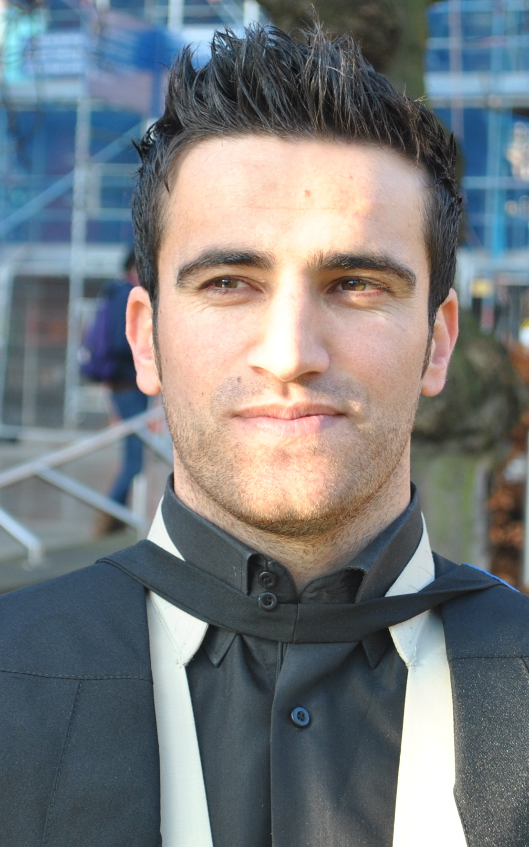
Curriculum Vitae

Surname: SALEM
Name: SALAR Mohammad Ameen SALEM
Date of Birth: 20th January 1987
Place of Birth: Zakho, Duhok
Gender: Male
Marital Status: Married
Nationality: Kurdish Iraqi
Address: NO. 9 Rejeen/ Zakho/ Duhok/ Kurdistan Region/ Iraq
Address for correspondence: Dep. Soil & Water. Faculty of Agriculture. University of Duhok. Kurdistan Region. Iraq.
Phone Number: 0964-750- 478 1844
E-mail Address: saleryo@yahoo.com

EDUCATION & QUALIFICATION
Schooling:
1992-1995 Begova primary school. Begova.
1995-1998 Rezgari primary school. Zakho.
1998-2003 Khabur secondary school. Zakho.
2003-2005 Zakho secondary school. Zakho.
University:
2005-2009 B.Sc. Study in the Soil & Water Science Dep. Faculty of Agriculture and Forestry. University of Duhok. Kurdistan Region. Iraq.
Rank is, 1st out of 21 students.
2012-2013 Master degree about Environmental Consultancy at Newcastle University. Newcastle Upon Tyne. United Kingdom.
Employment
2009-2010 Demonstrator at Soil & Water Science Dep. Faculty of Agriculture. University of Duhok. Kurdistan Region. Iraq.
2012 till now Assistant Lecturer at Soil & Water Science Dep. Faculty of Agriculture. University of Duhok. Kurdistan Region. Iraq.
EXPERIENCE & TRAINING
- After graduating in 2009, I was employed at 19/10/2009 at the University of Duhok as teaching and researching assistant in soil laboratory, fundamental of soil science, soil chemistry, soil fertility, irrigation system and drainage. Furthermore supervising student’s summary training course.
MEMBERSHIP
- Member of the Kurdistan Agronomist Syndicate since 2010.
- Member of the European-Kurdistan Green Organization since 2013.

LANGUAGE
- KURDISH Mother Tongue
- ENGLISH Fluent
- TURKISH Fluent
- ARABIC Reading writing understanding
RESEARCH INTERSETS
- Environmental Sciences
-Chemistry of Petroleum
- Soil and Water Sciences
- Agricultural Sciences
OTHER ACTIVITIES
Reading science books, Swimming, Football, and gym.

