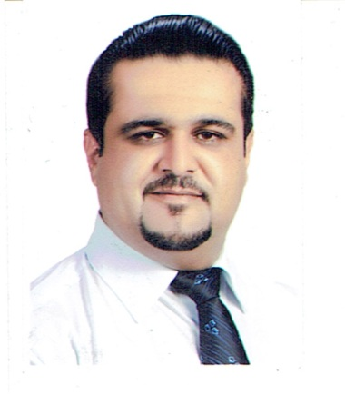
Full Name: MOHANAD ABDULJABBAR KADHIM
Date and place of birth: 15/8/1979 BAGHDAD-IRQ

Passport Number: G1292180

Address: Kurdistan/Duhok/Avro city/Building B30/Flat number 1
Mobile: 07507356108
e.mail: dr-mohanadduhok@uod.ac
Nationality: Iraqi/Arabic
Gender: Male
Marital state: Married

Educational background:
-Bachelor of dentistry/2005/College of Dentistry/Al-Mustansiriya university.
-Master of science in Oral Medicine/2012/ College of Dentistry/Al-Mustansiriya university.

Areas of experience:
-Period from 11/2005 to 2/2007 as a rotator dentist in Al-Awiya specialized dental center/Baghdad/Iraq.
-Period from 4/2007 to 6/2008 as a rotator dentist (for the second time) in Duhok specialized dental center/Duhok/Kurdistan.
-Period from 6/2008 to 11/2009 as a graduated dentist in Zirka health center/Duhok/Kurdistan.
-Period from 11/2009 to 6/2012 as a master's student in College of Dentistry/Al-Mustansiriya university/Baghdad/Iraq.
-Period from 6/2012 to 11/2012 as a specialized dentist in Duhok specialized dental center/Duhok/Kurdistan.
-Period from 11/2012 to 3/2016 as an assistant Lecturer in College of Dentistry/University of Duhok.

International activities:
-Attendance as a participant in training course of drugs marketing/Beirut/Lebanon/2011.
-Attendance as a participant in 15th international Conference of Behcet's disease/Yokohama/Japan/2012.
-Publication of an article in (Journal of drugs in Dermatology)/USA/2013 under title of (Therapeutic Role of Isotretinoin in Management of Behcet's disease: Single blind controlled therapeutic study.
-Publication of an article in (Journal of scientific research)/USA/2015 under title of (Therapeutic Role of Isotretinoin in Management of Recurrent Aphthous Stomatitis: Single blind controlled therapeutic study.

Local activities:
-participant in workshop about health care in detentions/Irbil/Kurdistan/2008.
-Attendance of second medical conference of faculty of medical sciences/Duhok/Kurdistan.
-Participant in workshop about dental implants/school of Dentistry/Duhok/2013.
-Lecturer in SECOND SCIENTIFIC NATIONAL CONFERENCE
FOR IRAQI DENTAL COLLEGES
BAGHDAD 10-11/4/2013.
-Lecturer in workshop about Oral Cancer in General Directirate of Health in Duhok/2014.
-Participant in workshop about prosthodontics/School of Dentistry/Duhok/2015.
-Participant in workshop about examinations/Faculty of Medical Sciences/Duhok/2015.
-Participant in Teaching methods course/University of Duhok/2015.
-Participant in workshop about sterilization/College of Dentistry/Duhok/2015.

Language:
English, Arabic and Kurdish.

Computer literacy:
Power Point, Word and Excel.

References:
-Dr.Bahar Jaafar Selivany (Lecturer/Dean of College of Dentistry/Duhok)
Tel: 07504544975
E.mail: dr.bahar_selivany@yahoo.com

Dr.Munther Kazanji (Assistant Professor/College of Dentistry/Duhok)
Tel: 07502089267
E.mail: munthern.kazanji@yahoo.com

