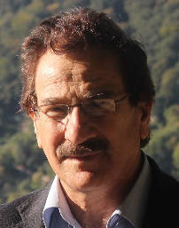

CV

Name: Dr. Sagvan Khalil Muhammad Hidayat
Date and place of birth: 1953, Zakho, Kurdistan region, Iraq.
Graduation:
Acquired MB ChB degree on 1979, medical college, Mosul University.
Acquired DMRD degree on 1989, medical college, Mosul University.
Worked as a sonologist in Azadi teaching hospital from 1991 till 2000.
Worked in CT scan unit form April 2000 till 2012.
Worked in MRI and CT units since 2012 till now.
A lecture in Duhok medical college as a staff member since 1996.
Sharing in the training of trainees and postgraduate students in Azadi teaching hospital.
Training courses and conferences:
A training course for 14 days on CT scan in Verona, Italy on Feb, 2010.
Shared in
“ECR” European conference of radiologists” on Mar 2010, Vienna, Austria.
Mesopotamia congress, Diyarbakir, Turkey, 2012.
Medical conference of Duhok University. Duhok, 2012.
Mesopotamia congress, Mardin, Turkey, 2014
Mesopotamia congress, Wan, 2015.
Published papers:
1. Acute head trauma, CT scanning study, DMJ, 2007.
2. Sonographic evaluation of fetal length in gestational age estimation, DMJ, 2009.
Residence: Shakhke, Duhok.
Mobile: 07504987907
E-Mail:sagvanhidayat@yahoo.com

