Curriculum Vitae

MohammedaminYaseenTaha (B.Sc. M.Sc. Ph.D.)
(Agriculture, Forestry, Forest Utilization)

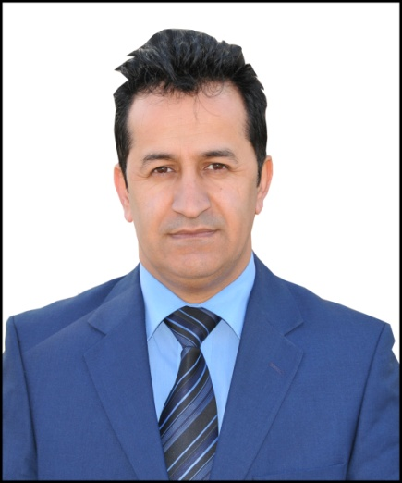

Collage of Agricalture
University of Dohuk
KurdistanRegionGovernment-Iraq
Dohuk, Avrocity
E-mail:mohammed.amin@uod.ac
Mobile Phone:+964 750 4722917
Surname: Taha
Forenames:MohammedaminYaseen
Gender: Male
Marital Status: Married.
Date and Place of Birth:3.04.1971 Amedy, Duhok, Iraq
Specialization: Forest Utilization
Position: CollegeVice Dean
Scientific Degree: Lecturer
Work Address:Department of Forestry, Collage of Agriculture, University of Duhok, Duhok, Sumail, Kurdistan Region, Iraq.

Originally from Duhok Province in Kurdish part of Iraq (Southern Kurdistan), I was Born 3.04.1971 in Amedy – Iraq. I did my primary, secondry and high school educations in Iran. In 1993 we returned to Kurdistan and was admitted at university of Duhok and graduated with a BA degree in Agricaltural Collage . In 2002, I continued with my education and I did my Master in the field of Forestry, Forest Utilization studies from Dohuk University . Following that in 2009 I started my PhD in the field of Forest Utilization at University of Dohuk.
I have been working as a memmber in Engineering Agronomist Sendicate of Dohuk in Kurdistan Region from 1997 untile 2016 and as adminstative memmber of that Sendicate from 2004 untile 2012 . I have also worked closely as in Lab. Assistance from 1998 to2004 at Collage of Agriculture, also in sustaine with College as Assisstant Lecturer from 2004 to 2009. Kurdish is my mother tongue and I also speak fluently 3 more languages: Persian, Azeri, Arabic and English.

LANGUAGE PROFICIENCY
- Kurdish: mother tongue.
- English, Persian, Azeri: fluent (spoken and written).
- Arabic: working knowledge (spoken and written).

CURRENT POSITION
- Since14.10.2014Vice Dean at the Collage of Agriculture, Duhok University.
- Teaching staff member at the department of Forestry, Collage of Agriculture, and University of Duhok.

EMPLOYMENT
- 1997-2002 Demonstrator and Research assistant at Forestry Dept., College of
Agriculture, University of Duhok.
- 2004-2009 Assistant lecturer, Dept. of Forestry, College of
Agriculture, University of Duhok, Kurdistan, Iraq.
- 2004-present time, Teaching staff member at the Department of Forestry, College of
Agriculture, University of Duhok, Kurdistan, Iraq.

PERSONAL EXPERIENCE
- Teaching undergraduate courses in Forest Utilization, and Forest Road Engineering and Non Timber Forest products.
- Teaching postgraduate study course in Adv. Forest Utilization.
- Supervision of undergraduate students’ graduation projects and seminars.

EDUCATION
- Schooling:
- 1978-1983Azhdar primary School,Iran- Tabriz.
- 1984-1986 Amin Intermediate School, Iran- Tabriz.
- 1987-1991Welayet Secondary School, Iran- Tabriz.
(B) University:
-1993-1997B.Sc. study in the Dept. of Plant Production , College of Agriculture,University of Dohuk, Iraq.
- 2002 -2004M.Sc. study in the Dept. of Forestry, College of Agriculture, University of University of Dohuk, Iraq.
- 2009- 2013PhDin Forest Utilization. study in the Dept. of Forestry, College of Agriculture, University of University of Dohuk, Iraq

ATTENDED CONFERENCES
- The first Agricultural Conference at the Faculty of Agriculture, Dohuk University. October, 2012.
- The second Agricultural Conference at the Collage of Agriculture, Dohuk, University. 26-27 April, 2016.

TRAINING AND WORKSHOPS
- April 2004Arnold BREGSTRASER Institute – Aleppo University IKARDA- Syria
Visiting ResearcherCOLLAGE MEMBERUniversity of Dohuk
- April 2008 ILTES English language course in cultural center in University of
Dohuk, Kurdistan, Iraq.

- April 2009 GIS and Remote Sensing course ITC Netherland in cultural center in University ofDohuk, Kurdistan, Iraq.

RESEARCH AND PUBLICATIONS
  - PhD dissertation entitled “POSSIBILITY OF SAWN BOARD PRODUCTION FROM (Eucalyptus Camaldulensis)GROWING IN KURDISTAN REGION OF IRAQ.Colleg of Agriculture, University of Duhok, Iraq 2013.
  - M.Sc. Thesis entitled “AIR SEASONING OF BLACK POPLAR(Populusnigra L.) WDOOD DOHUK PROVINCEColleg of Agriculture, University of Duhok, Iraq 2004.
  - An economic comparison between two administrative types for peach orchard in Duhok governorate. 2002. JDU. Vol. (5) No. (2), P. 33-43.
  - Using the Normal Prices to Determinate the Harvest Revenue and Losses with Regeneration Delay for Poplar Stand in Zakho.Journal of DohukUniversity.12(1)
53-57
  - Influences of Export Raw and Industrial Wood on Forest Utilization in Selected Countries (Indonesia, Malaysia).Journal of Mesopotamia, University of Mosul.
  - Testing of Winter Drying Defects on (Eucalyptus camaldulensis Den.) Sawn-Boards.Journal of Dohukuniversity. 16(1) 53-57.
  - Effect of Drying Factors on Properties of (Eucalyptus camaldulensis Den.) Boards at Summer Season.2013,Journal of Dohukuniversity. 16(2).
  - EFFECT OF DRYING METHOD AND WOOD SAWING ON MECHANICAL PROPERTIES OF Eucalyptus camaldulensisDen. 2014, Journal of Dohuk university. 16(2).
  - SOME TECHNOLOGICAL PROPERTIESOF SAWN BOARD Eucalyptus camaldulensisDenh.GROWN IN ASKIKALAK.2015,Journal of Zakhouniversity. 16(2).
  - Suitability of Eucalyptus camaldulensisdehnh.growing in Kurdistan region of Iraq for sawnlumber industry,2015.International Journal of Agronomy and Agricultural Research (IJAAR) Open accesses.

OTHER ACTIVITIES
  - Reading, Music, Football Sport …Others

MEMBERSHIPS
- Member of the Kurdistan Agronomist Syndicate since 1997
- Member of Teachers Syndicate-Duhok branch, Kurdistan 1998.
- Member of Kurdistan University and Institute Teachers Syndicate since August, 2010

