Curriculum Vitae
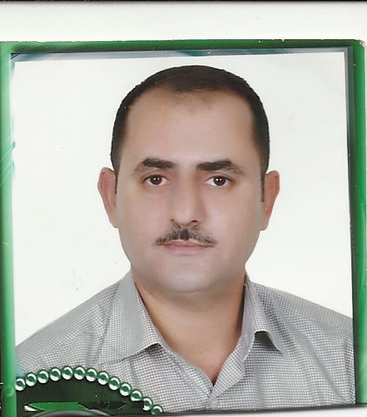
Sure Name | : Mubarak
Name | : Zahir Mahamad Tahir Ali
D.O.B | : 15 May 1974
Place of Birth | : Duhok, Iraq.
Sex | : Male
Marietal status | : Maried
Nationality | : Iraqi
Current Residency | :AvroCity,Duhok, Duhok,Iraq.
E-mail | : azad82d@gmail.com
Mobile | : 00 964 750 6648099
Tel | : 00 964 750 4720819

Present Post: lecturer of Pediatrics, Department of Pediatrics, College of Medicine, University of Duhok, attached as a pediatrician specialist to the Hevi pediatrics teaching hospital, Duhok, Iraq.
Qualifications :
- Primary and Secondary schools (1980-1992): (including eight years of English language courses), Graduated from the Kawa secondary school (Duhok, Iraq).

- Awarded the degree of Bachelor of Medicine and Surgery (MBChB): by the College of Medicine, University of Duhok , on June 1998. Ranked Forth on my class.

- Awarded the Degree of Fellow of Iraqi board for medical specialization in Pediatrics by the faculty of Iraqi board for medical specialization May 2008.

Post Graduation Posts :
- Junior House Officer (Rotational Internship) (15/09/1998-15/09/2000): a total of tweny four months, including:
- Azadi teaching hospital: (6 months medicine, 3 months surgery
3 months pediatric, 2months obstetric & gynecology,
3 months other branches)
- Hevi Pediatrics teaching hospital:6 months

- Emergency hospital:4 months
- Duhok emergency hospital:4 months
- General practetianal at Atrosh Primery health center (1/10/2008 till 16-09-2001),

- Senior house officer in pediatrics (16/09/2001 till 16-05-2008), at “Al-Khansaa pediatrics teaching hospital” in Mosul.

- Pediatrics specialist in Hevi pediatrics teaching hospital (1 /08/2008 till now) in duhok

Current work:
- Lecturer of Pediatrics at the Department of Pediatrics, College of Medicine, University of Duhok (2001 till know), and attached for the same period as a Pediatrics specialist to the Hevi Pediatrics Teaching Hospital.

The academic responsibilities include:
- Undergraduate lectures (Forth and fifth year pediatrics - medical students) on general pediatrics, Clinical and theory.

Professional responsibilities include:
- Pediatrician: treatment of inpatients, outpatient and emergency department of pediatrics and neonates since 2008.

Membership of Associations/Committees

- Member of Kurdish Medical association since 2000.
- Member of Kurdistan Pediatrics Society since 2012.
- Member of the Iraqi pediatrics Association November 2008

Date: 16th April, 2016

