Curriculum Vitae
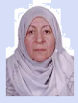
Sure Name | : Mahmoud
Name | : Walaa Yousif Mahmoud
D.O.B | : 1962
Place of Birth | : Mosul, Iraq.
Sex | : Female
Marietal status | : Married
Nationality | : Iraqi
Current Residency | : Derin City, Duhok,Iraq.
E-mail | : Walaayousif62@yahoo.com
Mobile | : 00 964 750 3419002

Present Post: Lecturer in Pediatric Department, College of Medicine, University of Duhok.attached as specialist for teaching medical student in hevi pediatric hospital &as specialist pediatrition for early detection & treatment of handicaps children in childhood rehabilatation center.
Qualifications :
- Primary and Secondary schools (1968-1980): (including eight years of English language courses), Graduated from the Kifah secondary school (Mosul, Iraq).

- Awarded the degree of Bachelor of Medicine and Surgery (MBChB): by the College of Medicine, University of Mosul , on the 7th of June 1986.

- Awarded the Degree of Fellow of Arabic board for medical specialization in pediatric by the faculty of Arabic board for pediatric specialization on the 1995.

Post Graduation Posts :
- Junior House Officer (Rotational Internship) (1/8/1986-1/1/1989): a total of eighteen months, including:
- General teaching hospital: (3 months medicine, 3 months surgery
3 months pediatric, 3 months obstetric & gynecology,
3 months other branches)
- Emergency hospital:3 months

- General practitioner at Mosul dam hospital. (director of the center)( 1/1/1989-1/1/1991): Duties:
- Direction of all activities in the center.
- Management of patients (out patients).
- Supervision on the vaccination programs.
- Supervision on the program of malnutrition.
- Supervision on the program of antenatal care.

- Senior house officer in pediatric department (1/1/1991 -20-11-1995), at “pediatric teaching hospital” in Mosul
A.Direction of all activities in the hospital.
B.Management of patients (out patients).
C.Supervision on the vaccination programs.
D.Supervision on the program of malnutrition.
E. Management of in patients.
F. Management of premature baby in intensive care unit
in premature department centre.

- Pediatric specialist in pediatric teaching hospital 21/11/1995 till 1/6/1998 in Mosul.

5. Lecturer in Pediatric Department, College of Medicine, University of Duhok. (4th , 5th ,6th year medical students) from 1/8/1998 till now.

.

SCIENTIFIC RESEARCH:-

- Dr. Walaa Yousif Mohmoud, Dr. Arif Hito. Enuresis study of 114 cases in Duhok city,in the Kurdish population of Northern Iraq. 3rd Qater international medical congress.2005.

- Dr. Walaa Yousif Mohmoud, Dr.Akram atroshi. Causes of breast feeding in the Kurdish population of Northern Iraq,Duhok city, Babil medical journal, 2014.

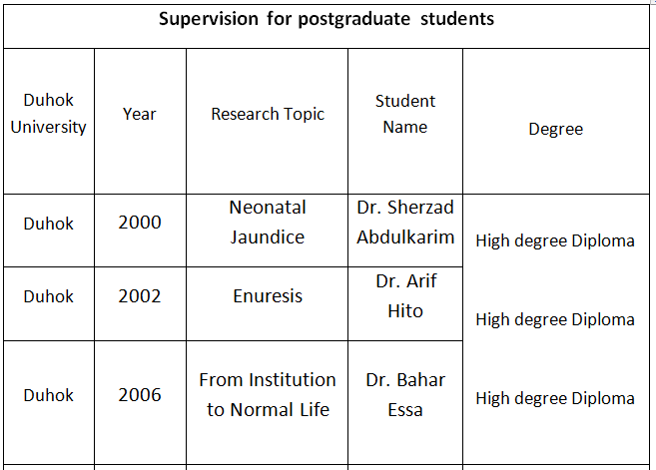

Current work:

- Lecturer in Pediatric Department, College of Medicine, University of Duhok. (4th , 5th ,6th year medical students) since 1998 till now.
- As specialist for clinical teaching of(4th , 5th ,6th year) medical students in hevi pediatric hospital. since 1998 till now.
C. As specialist pediatrition for early detection & treatment of handicaps children in childhood rehabilatation center. since 1998 till now.

Membership of Associations/Committees

- Member of Kurdish Medical association since 1998.
- Member of the International Iraqi Medical Association since 1986.
- Member of the Iraqi pediatrics Association.

Date: 29th February, 2016

