Dian Jamel Salih |  | Zozan Street  Duhok\ Kurdistan Region-Iraq  Phone cell: 07504568201  dian.jamel@uod.ac  dian_mizery@yahoo.com | 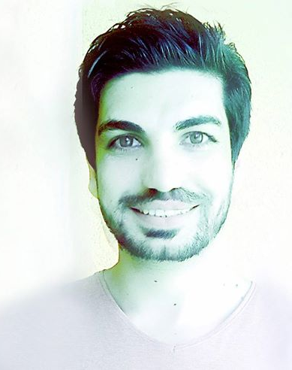
PERSONAL | Date of Birth: January 1, 1987  Gender: Male  Place of Birth: Duhok, Kurdistan Region-Iraq  Citizenship: Kurdish  Visa Status: Permanent Resident
EDUCATION | University of Duhok, Faculty of Medical Sciences  M.Sc. in Medical Cytogenetics  November 2013 – July 2015  Thesis: "Clinical and Cytogenetic profile in patients with Down syndrome in Duhok province, Kurdistan region of Iraq"  University of Duhok, College of Sciences  B.Sc. in General Biology  September 2006 - June 2010  Focus on General Aspect of Biology Sciences
EMPLOYMENT | University of Duhok, Faculty of Medical Sciences  January 1, 2012 - present  Assistant Lecturer  - Oversee Biology Laboratory Department  ………………………………………………………………………..........  University of Duhok, Directorate of Health and Safety/ UoD  December, 2015 - March 2016  Acting Manager of the Directorate  - Manage and supervise of any project related to health and safety in university of such as scientific laboratory, environment of building, cafeteria and Interior sections for Students.  ………………………………………………………………………..........  Shilan Private Hospital, Duhok City  February 2012 – December 2012  Laboratorist  - Dialed with laboratory experiments and diagnosis of diseases  ……………………………………………………………………………..  Piro Magazine for Tourism and Health, Duhok City  December 2011 – June 2012  Managing Editor  - Editing General Subjects and Threads  - Writing and Publishing Articles on Medical, Scientific and General Health Aspect  - Respond to all inquiries within work hours  ………………………………………………………………………………..  Kurdzoom Entertainment Magazine, Duhok City  January, 2006 – December, 2014  Assistant Manager  - Manager of Health and Medical Papers
SKILLS | Language:  - Fluent in Kurdish Language (Both Badini and Sorani Dialect)  - Fluent in Arabic Language  - Good in English  Computer Skills:  - Microsoft Office  - Photoshop  - SPSS  - Enternet  - Formate and install Windows
PUBLICATIONS | Journalism:  - Published more than 100 Articles and Reviews of Medical, Health and general scientific aspect in different newspapers, magazines and journals in Kurdistan region.  Books:  - Translated and published Six Medical textbooks from English to Kurdish language, which are (Microbiology, Molecular and Cell Biology, Endocrinology, Medical Parasitology, Genetics, Human Anatomy and Physiology).  - Translated and published three child Scientific Books from English to Kurdish language.
MEMBER | - Active member of the Kurdistan Biology Syndicate  - Active member of the Kurdistan Journalists Syndicate
CERTIFICATES | - ICDL International Computer Driving Licence Certificate, 2013.  - TOEFL English language Certificate, 2013.  - Driving license. 2011.  - Pearson Test of English Academic Certificate, 2015.  - Teaching Methodology course certificate, 2015.  - Scientific title, 2016.
REFERENCES | Available upon request

