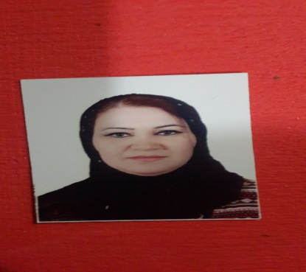
Duhok University
College Of Medicine
Department Of Anatomy
E-mail: Hayatsulaiman70@gmail .com
Tel: 0750 3044521
Curriculum Vitae
Name: HAYAT SULAIMAN AHMED
Surname: Ahmed
Place & Date of Birth: Ninawa,08/05/1977
Language: Kurdish, Arabic, English

Education:
1998 – 2003 B.V.M.&S, college of Veterinary Medicine / Duhok University
22/ 04 / 2008 M.SC. in Medical Histology/ College of Medicine/Duhok University

Thesis Title: Histological Examinations Of Placentae From Spontaneous Pregnancies And Those Obtained By Assisted Reproductive Technologies

Work &Training
01 / 10 / 2003: Employ (Demonstration) in Veterinary Medicine/ Duhok University
22/ 04/ 2008: Until now , Assist. Lecturer in College of Medicine / Duhok University
22/ 04/ 2008: Until now giving Lecturer of Histology to College of Medicine
01 / 11 / 2008: Gave lecturer of Histology to Zako Analysis Technique Institution
2010 until now giving Lecturer of Histology to College of Dentistry
2014-2015: Gave lecturer of Histology to College of Pharmacy

Hobbies:
Redding, doing researches, Traveling, Lessing to music

